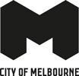

Melbourne Visitor Hub

Accessibility Guide

Updated June 2024

# Acknowledgment of Traditional Owners

The City of Melbourne respectfully acknowledges the Traditional Owners of the land we govern, the Wurundjeri Woi-wurrung and Bunurong / Boon Wurrung peoples of the Kulin Nation and pays respect to their Elders past and present. We acknowledge and honour the unbroken spiritual, cultural and political connection they have maintained to this unique place for more than 2000 generations.

We accept the invitation in the Uluru Statement from the Heart and are committed to walking together to build a better future.

# Contact Us

Address: Melbourne Town Hall, 90-130 Swanston Street (Corner Little Collins and Swanston streets), Melbourne 3000

Phone: 03 9658 9658 (Monday to Friday only)

Email [visitor@melbourne.vic.gov.au](mailto:visitor@melbourne.vic.gov.au)

Website: <https://whatson.melbourne.vic.gov.au/visitor-info/visitor-centres/melbourne-visitor-hub>

# Hours of Operation

Open daily 9am to 5pm.

**Contents**

Acknowledgment of Traditional Owners 2

Contact Us 2

Welcome 5

Access At A Glance 5

Our Staff 5

Social Script 6

What To Expect 6

Getting Here 6

Travel by tram 6

Travel by train 7

Flinders Street Station 7

Melbourne Central Station 7

Travel by car 7

On street parking 7

Off street parking 8

Arrival 8

Entrance 8

Retail 9

Service Counter 9

Visitor Assistance 10

Customer Feedback 11

Seating and Rest Areas 11

Adult Change Room 11

Additional Services 13

Peak Periods 13

Virtual Visitor Hub 14

Consultation 14

Availability 14

Bookings 14

Communication and Information 14

Sounds 15

Temperature Control 15

Lighting and Visual Stimulus 15

Scents 15

Additional Helpful Information 15

Access Map 15

Mobility equipment hire 15

Recharge points 15

Accessible and Inclusive Melbourne 15

Acknowledgement of Thanks 16

# 

# Welcome

Located in the centre of the city at the Town Hall, the Melbourne Visitor Hub is close to the retail, dining and laneways for which Melbourne is revered. Friendly staff and volunteers can help you plan your time in Melbourne and share the city's secrets with you.

The Melbourne Visitor Hub is committed to supporting a locally made and sustainable retail offering, through sourcing eco-friendly products and packaging.

# Access At A Glance

* Charging Point Accessible Parking
* Accessible Parking
* Wifi
* Step Free Access
* Assisted Listening Device
* Charging Station

# Our Staff

* We have a diverse friendly team of staff and volunteers available to share local knowledge and personal insights about Melbourne and regional Victoria.
* Our volunteers can provide advice on things to do and help you create a customised itinerary.
* Staff and volunteers wear name badges and red shirts with black trousers or skirts so they are easily recognised.
* Our staff and volunteers participate in an E-learning module on accessibility and are trained in the hidden disability Sunflower Scheme. They are happy for you to approach them and ask questions.
* Some of our staff and volunteers are multi-lingual and provide assistance in other languages as needed. These staff and volunteers wear 'language badges' so they are easily identified by visitors who need assistance in their foreign language

We look forward to welcoming you to the Hub and helping you to enjoy everything Melbourne and regional Victoria has to offer!

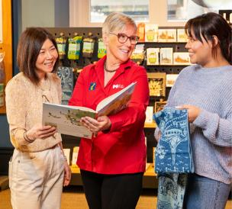

# Social Script

* I am going to visit the Melbourne Visitor Hub. It is a place where I can get help and information about Melbourne and regional Victoria. I can purchase souvenirs and gifts made by local businesses and I can purchase and top up myki.
* When I arrive, I will see the Melbourne Town Hall. I might see other people there, also looking for information.
* Inside, there are friendly staff and volunteers who can help me. I can ask them questions about things to do.
* Staff and volunteers can give me maps and brochures. They can help me find interesting places to visit.
* Staff and volunteers know a lot about things to do and places to see and if I need help planning my visit, they can give me advice.
* There are digital screens and iPads where I can find more information. I can use these screens to explore different attractions and events.
* It is okay to feel excited or a little nervous. The staff and volunteers are there to help me feel comfortable and answer any questions I have.
* I can use the information I get to plan my day in Melbourne. I might learn about special events, museums, parks, and more.
* When I am ready to leave, I will have lots of information to help me enjoy my visit. I can always come back if I have more questions or need more help.

# What To Expect

* When you arrive, friendly staff and volunteers will greet you and offer assistance.
* You may choose to browse the information provided or receive assistance from staff and volunteers.
* There is plenty of information about what’s on in Melbourne and regional Victoria including:
* How to get around and public transport
* Free [walking maps](https://whatson.melbourne.vic.gov.au/things-to-do/walks) of the city’s street art, laneways and arcades
* Guides, brochures and maps
* Locally sourced products and gifts are available for sale and you can peruse them at your leisure.
* New myki cards can be purchased and Myki top-up is available including myki Money and myki Pass.
* Installations are in place to inspire your exploration of the city.
* There is level access throughout the visitor hub and adequate clear floor space for mobility aids.
* Low-pile carpet is used throughout the hub.
* Free Wi-Fi and charging points are available.

# Getting Here

## Travel by tram

* The nearest tram stop is Melbourne Town Hall/Collins Street #6 with routes 109, 11, 12, 48. The tram stop is approximately 95m from the Melbourne Town Hall entry.
* The next closest tram stop is City Square/Swanston Street with routes 1, 16, 3, 5, 6, 64, 67, 72. The tram stop is approximately 105m from the Melbourne Town Hall entry.
* Tram routes 109, 11, 48, 5, 6, and 16 all offer low-floor tram options. Check [Public Transport Victoria](https://www.ptv.vic.gov.au/stop/2491/melbourne-town-hallcollins-st-6/1/tram/#StopPage:::datetime=2024-07-03T09%3A34%3A19.812Z&directionId=-1&showAllDay=false&_auth=e15a49021bd59d300bc6c8d1949040c0fc48ff3be16ffd38d61e1e6c2f6df790) for the times of the Low-floor options.
* These stops are included in the free tram zone.
* A step-free route is available from the tram stops.

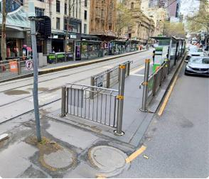

## Travel by train

### Flinders Street Station

* This station has accessible station access.
* The station is approximately 300m from the Melbourne Town Hall entry.
* A step-free route is available from the train station.

### Melbourne Central Station

* This station has accessible station access.
* The station is approximately 550m from the Melbourne Town Hall entry.
* A step-free route is available from the train station

## Flinders street station, Melbourne, Australia at night time lit up with a golden hue.

## Travel by car

### On street parking

* There is limited time-restricted street parking on Collins Street including accessible parking.
* Once you are on the footpath, there is a continuous accessible path of travel to the entry. Access to the footpath is via the nearby traffic lights where there is a kerb ramp.
* Visit [Parking for people with disability](https://www.melbourne.vic.gov.au/parking-and-transport/parking/pages/parking-for-people-with-disabilities.aspx) to find and navigate to parking spaces reserved for people with disability.

### Off street parking

* The nearest paid off- street parking is 233-239 Collins Street.
* This parking is approximately 100m from the Melbourne Town Hall entrance.
* Please visit the City of Melbourne’s [Off Street Parking](https://www.melbourne.vic.gov.au/parking-and-transport/parking/Pages/off-street-parking.aspx) for more information on car park locations and Council operated car parks.

# Arrival

* The path approaching the entrance is paved.
* There is step-free access from the frontage to the entrance.
* Warning and Directional Tactile Ground Surface Indicators assist with the navigation of the nearby intersection.

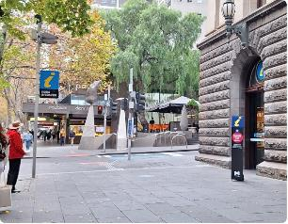

## Entrance

* Clear signage indicates the entrance to the Visitor Hub.
* A clear and step-free path of travel leads to the entrance.
* Automatic glass sliding doors with visual indicators provide access to the Hub.
* 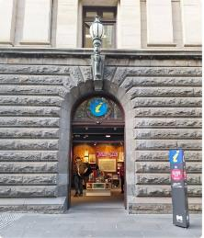The clear door width is greater than 1000mm.

# The view of looking out to the street from inside the hub. There are large open wooden doors beside the automotive glass sliding doors.

# Retail

* You will enter the retail area of the visitor hub, featuring a variety of locally sourced products and gifts.
* Items are displayed between floor level up to 1600mm.
* There is clear floor space with a minimum width of 1000mm surrounding all display stands
* You are welcome to touch the products for a closer look but be careful and respectful of the items. You can ask staff and volunteers for assistance to view any products.
* 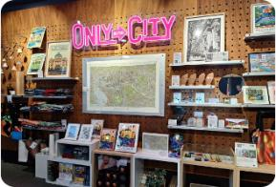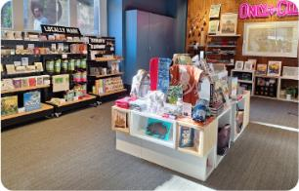We accept card transactions and do not accept cash transactions.

# Service Counter

* The customer service counter is located between the retail and visitor information area. This service counter has a height of 1000mm.
* A hearing loop is installed at this counter.
* Our staff and volunteers are mobile and are not always stationed behind this desk. As soon as you need assistance we will approach to help you.

# Visitor Assistance

* + - Staff and volunteers will approach you and offer personal assistance with planning all aspects of your trip.
    - Information about what to do in Melbourne and regional Victoria is offered including:
    - Support navigating booking processes.
* Information about booking agencies for local events and experiences.
* Details on how visitors can access support services, such as personal assistants or guides, and any partnerships with local disability services.
  + - Support to connect with Travellers Aid.
    - Your itinerary, guides and maps, or information discussed can be shared with you via email on request.
    - There is a selection of assistance counters of varying heights including two height-adjustable hydraulic desks with the lowest height of 780mm and an overhang of 280mm.
    - The Information Service Counter is set at a height of 1050mm and an accessible height of 770mm.
    - A height-adjustable tablet is available to access digital information as well as digital touchscreens.
    - There is clear floor space with a minimum width of 1000mm surrounding all display stands.

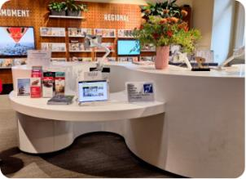

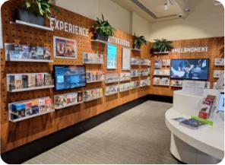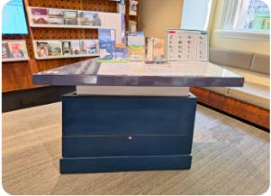

# Customer Feedback

* We invite feedback on your experience when visiting the Melbourne Visitor Hub. You can provide feedback via the Feedback Tablet which is located at the entrance. Staff and volunteers can assist with this as required.
* 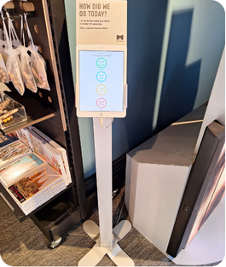The tablet is positioned at a height of 1000mm.

# Seating and Rest Areas

* Cushioned bench seating is available when you want to take a break.
* The seating has a height of 440mm.

# Adult Change Room

* Location: Ground floor, Melbourne Town Hall
* Accessed via an MLAK key which is available from Security.
* You will have the opportunity to use the facilities before and after the tour, there is limited opportunity to visit the facilities during the tour.
* There is an adult changing facility with a ceiling hoist.
* A shower with a handheld shower hose and fold-down shower chair.
* Privacy screen.
* An accessible toilet with drop-down rails on the right and left side.
* A manual wheelchair is available for use.
* Visit [Getting Around Melbourne](https://www.melbourne.vic.gov.au/community/health-support-services/accessing-melbourne/Pages/getting-around-melbourne.aspx) to find more Adult Change rooms in the city

# The large adult changing places room with an accessible toilet, shower, basin, hoist and adult change table.

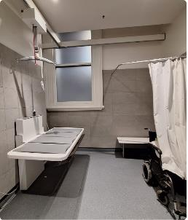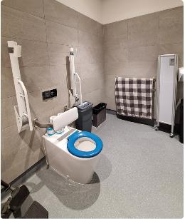

RHS Accessible Toilet

* Location: Ground floor, Melbourne Town Hall
* You will have the opportunity to use the facilities before and after the tour, there is limited opportunity to visit the facilities during the tour.
* The manual door is inswinging to the left and has a clear width of 860mm. The door to enter the toilet has a D-shaped lever handle with a height of 1000mm. There is a long lever lock.
* The toilet has a height of 450mm. The clearance on the right side of the toilet is 270mm and on the left it is open. Grab rails are located on the right side and rear of the toilet and are positioned with a height of 800mm.
* The basin has a height of 1100mm with a lever-style tap. The soap dispenser has a height of 1000mm. The hand dryer is positioned next to the basin with a height of 1000mm.
* Lighting is automatic.

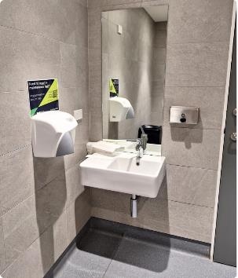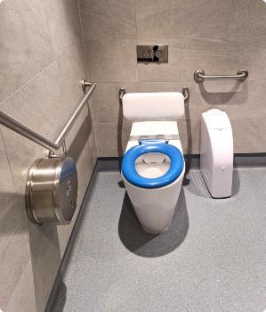

# Additional Services

* Charging Points: Charging points are available in the visitor centre, please bring your own charging cable.
* Free Wi-fi: Free City of Melbourne Wi-fi can be accessed anywhere in the visitor centre.
* Free Maps and Brochures: Free maps and brochures are available to help plan and inspire your visit.

# Peak Periods

* Peak days and times at the visitor hub vary depending on the season, school holidays, and what other events are happening in the city. In general
  + Monday to Thursday mornings are busy.
  + Fridays and Saturdays are busy all day but the mornings are generally busier.
* These peak periods depend on events happening in the city and if you would like more information about the best time to visit, please call ahead and speak with our friendly team.

# Virtual Visitor Hub

Can't make it in to a visitor centre? Book in a time with one of our dedicated tourism staff to help plan your next trip to Melbourne or regional Victoria.

## Consultation

* The virtual visitor consultation offers:
* Local knowledge and personal insights
* Customised itineraries
* Access to online maps and walks
* Advice on things to do and how to get around
* Consultations run for up to 20 minutes and can be held by phone or online via Microsoft Teams. Phone consultations are available to Australian numbers only.

## Availability

* Consultations are available Monday to Sunday from 9.30am to 4.30pm.

## Bookings

* Complete the form to [request a virtual visitor consultation](https://comdigital.wufoo.com/forms/q17lne7f13fbxa9/). Please allow one business day for bookings to be confirmed.
* Alternatively, email visitor@melbourne.vic.gov.au with your tourism enquiries.
* <https://whatson.melbourne.vic.gov.au/visitor-info/virtual-visitor-hub>

# Communication and Information

* Our staff and volunteers deliver information verbally.
* There are information signs throughout the visitor hub and staff can assist with reading and sharing this information.
* Information is provided in a range of formats including visual, audio, digital and printed.
* Most printed and digital material is produced by a third party, we will assist with providing this in alternative formats where possible however we have little control over the accessibility of this material.
* Most material is available in digital alternatives and can be used with the magnification feature of the tablet.
* A Roger Hearing System is installed, ask for the T-switch receiver at the customer service counter.
* Communication boards are available on request.
* QR codes are available to access information such as self-guided walks and itineraries and to learn more about some of the locally sourced retail items and artists.

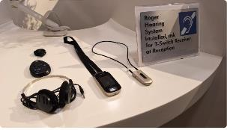

# Sounds

* There are typically few sounds in the Melbourne Visitor Hub besides the conversations of tourism staff and other visitors.
* The volume of other guests will depend on the number of other people visiting the hub at the same time as you.
* You may hear gentle traffic sounds such as when you are near the door as it faces the street.
* You may hear the Wominjeka message as you enter the Hub. The message is set at a low volume and can be adjusted to suit your needs. It can also be connected to the Hearing Loop on request.
* There may be gentle background music, this can be adjusted on request.

# Temperature Control

* The temperature is controlled by Facilities and cannot be adjusted.
* The temperature may vary depending on the season and the frequency of the doors opening.

# Lighting and Visual Stimulus

* TV screens are in some areas of the hub displaying information about things to do and places to visit.
* Lighting varies throughout the hub ranging from 400 to 2500 lux depending on the level of natural light.
* Lighting is mostly consistent throughout the space, there may be glare near the windows and door.

# Scents

* Scented Products: Strong scents of local products such as diffusers and candles can be found in the retail area.
* Flowers: Fresh flowers may be on display throughout the hub.
* Hand Sanitisers: Hand Sanitiser may be located at the service counters.
* Air Freshener: Air fresheners may be used on occasion.

# Additional Helpful Information

## Access Map

Visit the City of Melbourne [Access Map](https://www.accessmap.melbourne.vic.gov.au) for more information on accessible amenities.

## Mobility equipment hire

Visit [Travellers Aid](https://www.travellersaid.org.au) to hire various mobility equipment while you’re in Melbourne.

## Recharge points

Visit [Services for People with Disability](https://www.melbourne.vic.gov.au/community/health-support-services/accessing-melbourne/Pages/disability-services.aspx) to find your nearest recharge points for your electric scooter or wheelchair. The power points recharge the batteries for standard mobility aides, you will need to bring your own battery charger.

## Accessible and Inclusive Melbourne

Visit [Accessible and Inclusive Melbourne](https://whatson.melbourne.vic.gov.au/article/accessibility-in-melbourne) on our What's On Melbourne website to learn more about local accessible experiences. There's a great range of accessible and inclusive experiences to enjoy in Melbourne.

# Acknowledgement of Thanks

The City of Melbourne would like to acknowledge the support and assistance provided by Flare Access Pty Ltd in helping to prepare this Accessibility Guide.

This Accessibility Guide was designed and developed by Flare Access Pty Ltd. For feedback on the guide please contact the City of Melbourne.

Copyright the City of Melbourne June 2024. DISCLAIMER: Accessibility Guide developed by Flare Access. Observations made by Flare Access and additional information provided by the City of Melbourne. All materials have been compiled from information available at the time of production. They are not intended to replace professional advice including; but not limited to, access audits. All necessary care has been taken to design and produce Work(s). All measurements provided are within an approximate range. Full implementation guidelines are supplied in accordance with Work(s) in its entirety. You acknowledge and agree that you are using all services and facilities provided by the City of Melbourne at your own risk and you agree to defend, indemnify, save and hold the City of Melbourne and Flare Access Pty Ltd harmless from any and all demands, liabilities, costs, losses and claims, howsoever suffered, including but not limited to legal fees that may arise directly or indirectly from any service provided or agreed to be provided by the City of Melbourne and Flare Access Pty Ltd. You agree that this indemnification extends to all aspects of the Work(s), including but not limited to implementation and usage. The City of Melbourne and Flare Access Pty Ltd are indemnified of all claims, liability, and expenses that may arise from use of Work(s) as per usage and acceptance of these terms and conditions.