

Fitzroy Gardens Visitor Centre

Accessibility Guide

Updated June 2024

# Acknowledgment of Traditional Owners

The City of Melbourne respectfully acknowledges the Traditional Owners of the land we govern, the Wurundjeri Woi-wurrung and Bunurong / Boon Wurrung peoples of the Kulin Nation and pays respect to their Elders past and present. We acknowledge and honour the unbroken spiritual, cultural and political connection they have maintained to this unique place for more than 2000 generations.

We accept the invitation in the Uluru Statement from the Heart and are committed to walking together to build a better future.

# Contact Us

Address: Fitzroy Gardens, Wellington Parade, East Melbourne 3002

Phone: 03 9658 9658 (Monday to Friday only)

Email: [visitor@melbourne.vic.gov.au](mailto:visitor@melbourne.vic.gov.au)

Website: <https://whatson.melbourne.vic.gov.au/visitor-info/visitor-centres/fitzroy-gardens-visitor-centre>

# Hours of Operation

Open daily 9am to 4pm.

Acknowledgment of Traditional Owners 2

Contact Us 2

Hours of Operation 2

Welcome 5

Access At A Glance 5

Our Staff 5

Social Script 6

What To Expect 6

Getting Here 6

Travel by tram 6

On street parking 7

Off street parking 7

Arrival 8

Entrance 8

Retail 9

Visitor Assistance 9

Customer Feedback 10

Seating and Rest Areas 10

Additional Services 10

Peak Periods 11

Communication and Information 11

Sounds 11

Lighting 11

Scents 11

Temperature Control 12

Virtual Visitor Hub 12

Consultation 12

Availability 12

Bookings 12

KereKere Green Cafe 13

About KereKere Green Cafe 13

Trading Hours 13

Peak Times 13

Quiet times 13

Contact details 13

Entrance to KereKere Green Café 13

Service Counter 14

Indoor Service Counter 14

Outdoor Service Counter 14

Allergens 14

Indoor Dining 14

Furniture 14

Outdoor Dining 15

Furniture 15

Toilets 16

Accessible Toilet 16

Additional Helpful Information 17

Access Map 17

Mobility equipment hire 17

Recharge points 17

Accessible and Inclusive Melbourne 17

Acknowledgment of Thanks 18

# Welcome

Set in the heritage-listed [Fitzroy Gardens](https://whatson.melbourne.vic.gov.au/things-to-do/fitzroy-gardens), this visitor centre is your first stop from which to explore the beautiful surrounds and [Cooks' Cottage](https://whatson.melbourne.vic.gov.au/things-to-do/cooks-cottage).

Speak to the friendly team about the attractions at the gardens and get their tips for the best local spots to visit.

# Access At A Glance

* Accessible Toilet
* Accessible Parking
* Step Free Access
* Accessible Outdoor Dining
* Accessible Indoor Dining
* Charging Point
* Baby Changing Table
* Baby High Chair

# Our Staff

* We have a diverse and friendly team of staff and volunteers available to share local knowledge and personal insights about Melbourne and regional Victoria.
* Our staff and volunteers can provide advice on things to do and help you create a customised itinerary.
* Staff and volunteers wear name badges and red shirts with black trousers or skirts so they are easily recognised.
* Our staff and volunteers participate in an E-learning module on accessibility and are trained in the hidden disability Sunflower Scheme and are happy for you to approach them and ask questions.
* Some of our staff and volunteers are multi-lingual and provide assistance in other languages as needed. These staff and volunteers wear 'language badges' so they are easily identified by visitors who need assistance in their foreign language.

We look forward to welcoming you to the visitor centre and helping you to enjoy everything Melbourne and regional Victoria has to offer!

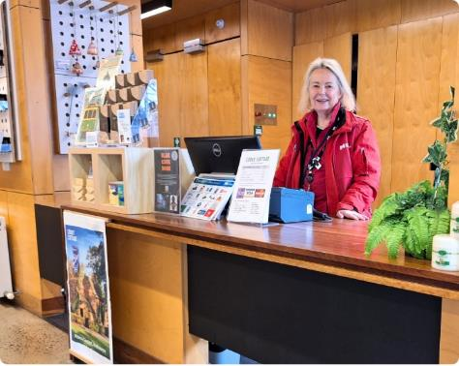

# Social Script

* I am going to visit the Fitzroy Gardens Visitor Centre. It is a place where I can get help and information about Melbourne and regional Victoria.
* I will walk through Fitzroy Gardens to arrive at the centre. I might see other people there, also looking for information.
* Inside, there are friendly staff and volunteers who can help me. I can ask them questions about things to do.
* Staff and volunteers can give me maps and brochures. They can help me find interesting places to visit.
* Staff and volunteers know a lot about things to do and places to see and if I need help planning my visit, they can give me advice.
* There are digital screens where I can find more information. I can use these screens to explore different attractions and events.
* It is okay to feel excited or a little nervous. Staff and volunteers are there to help me feel comfortable and answer any questions I have.
* I can use the information I get to plan my day in Melbourne. I might learn about special events, museums, Fitzroy Gardens, surrounding areas, points of interest like Cooks' Cottage and more.
* When I am ready to leave, I will have lots of information to help me enjoy my visit. I can always come back if I have more questions or need more help.

# What To Expect

* When you arrive, friendly staff and volunteers will greet you and offer assistance.
* You may choose to browse the information provided or receive assistance from staff and volunteers.
* There is plenty of information about what’s on in Melbourne and regional Victoria including:
* How to get around and public transport.
* Free walking maps of the city’s street art, laneways and arcades.
* Guides, brochures and maps.
* Locally sourced products and gifts are available for sale and you can peruse them at your leisure.
* Installations are in place to inspire your exploration of the city.
* There is level access throughout the visitor centre and adequate clear floor space for mobility aids.
* Concrete flooring is used throughout the centre.
* Free Wi-Fi and charging points are available.
* KereKere Green cafe is attached to the centre helping you relax and enjoy your visit.

# Getting Here

## Travel by tram

* The nearest tram stop is Jolimont Rd/Wellington Parade with routes 48 and 75. The tram stop is approximately 100m from the Fitzroy Gardens Visitor Centre entry.
* These routes offer low-floor tram options. Check [Public Transport Victoria](https://www.ptv.vic.gov.au/stop/2491/melbourne-town-hallcollins-st-6/1/tram/#StopPage:::datetime=2024-07-03T09%3A34%3A19.812Z&directionId=-1&showAllDay=false&_auth=e15a49021bd59d300bc6c8d1949040c0fc48ff3be16ffd38d61e1e6c2f6df790) for the times of the Low-floor options.
* This stop is outside of the free tram zone.
* A step-free route is available from the tram stops.

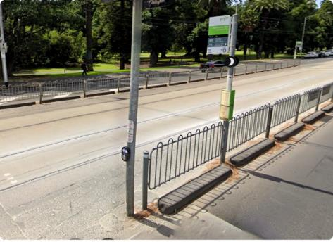

### On street parking

* There is limited time-restricted street parking on Wellington Parade.
* Once you are on the footpath, there is a continuous accessible path of travel to the entry. Access to the footpath is via the nearby driveway where there is a kerb ramp.
* Visit [Parking for people with disability](https://www.melbourne.vic.gov.au/parking-and-transport/parking/pages/parking-for-people-with-disabilities.aspx) to find and navigate to parking spaces reserved for people with disability.

### Off street parking

* The nearest off street parking is on-site at the visitor centre where there is limited parking.
* One accessible parking bay is available.
* Please visit the City of Melbourne’s [Off Street Parking](https://www.melbourne.vic.gov.au/parking-and-transport/parking/Pages/off-street-parking.aspx) for more information on car park locations and ​​​council-operated car parks.

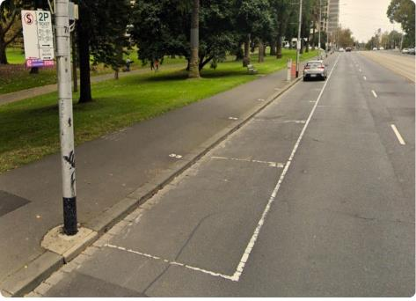

# Arrival

* The path approaching the entrance is concrete
* 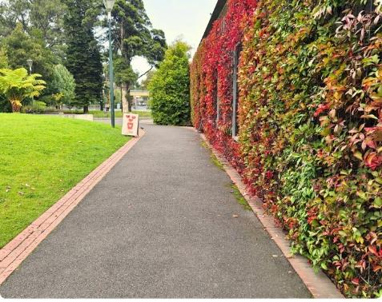There is step-free access from the frontage to the entrance.

## Entrance

* Clear signage indicates the entrance to the visitor centre.
* A clear and step-free path of travel leads to the entrance.
* Automatic glass sliding doors with visual indicators provide access to the visitor centre.
* The clear door width is greater than 1000mm.
* There is level concrete flooring throughout the visitor centre.

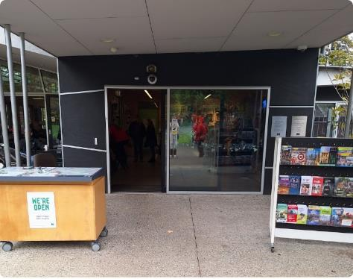

# Retail

* You will enter the retail area of the visitor centre, featuring a variety of locally sourced products and gifts.
* Items are displayed from 200mm to 2000mm and assistance is available to access items as needed.
* There is clear floor space with a minimum width of 1000mm surrounding all display stands.
* The customer service counter where you can make purchases is located inside the visitor centre.
* 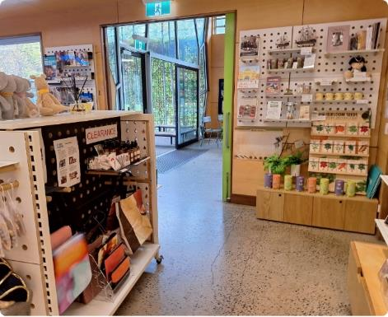This service counter has a height of 860mm and has unrestricted knee and foot clearance.

# A woman wearing red is standing behind the counter at a centre smiling at the camera.Visitor Assistance

* Staff and volunteers will approach you on arrival and offer assistance with planning all aspects of your trip.
* Information about what to do in Melbourne and regional Victoria is offered including:
* Support navigating booking processes.
* Information about booking agencies for local events and experiences.
* Details on how visitors can access support services, such as personal assistants or guides, and any partnerships with local disability services.
* Support to connect with Travellers Aid.
* Your itinerary, guides and maps, or information discussed can be shared with you via email.
* There is a selection of assistance counters of varying heights ranging from 860mm to 1050mm.
* There is an iPad counter with links to relevant websites. iPads are fixed but there is a secondary transportable iPad that you may access with assistance from staff and volunteers.
* 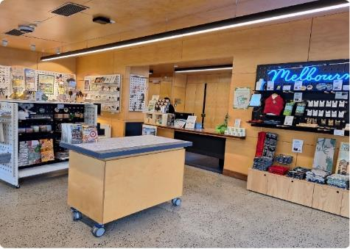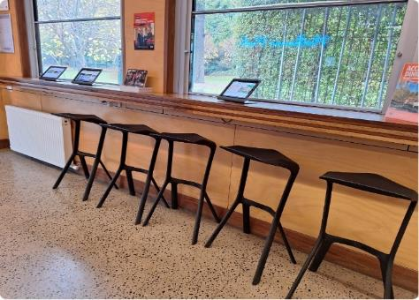A small self-service display is available at the front entrance with a map, these are available 24 hour.

# Customer Feedback

* We invite feedback on your experience when visiting the Fitzroy Gardens Visitor Centre. You can provide feedback via the Feedback Tablet which is located next to the customer service counter. Staff and volunteers can assist with this as required.
* 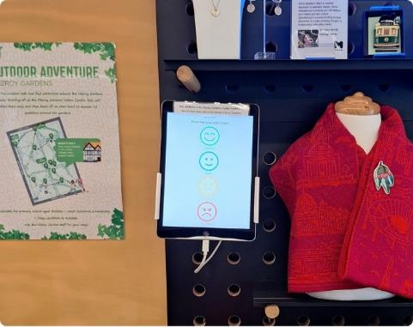The tablet is positioned at a height of approximately 1500mm.

# Seating and Rest Areas

* The seating inside the visitor centre offers a bench with a height of 1050mm.
* Stools without armrests are available with a height of 770mm.
* There is further seating available at KereKere Green Cafe.

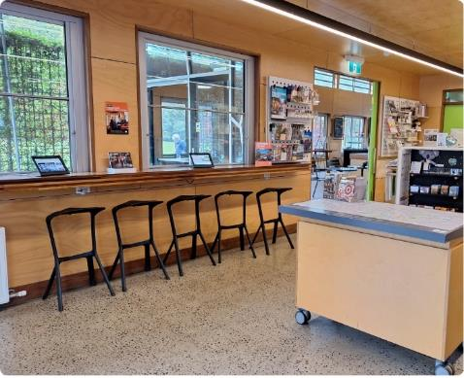

# Additional Services

* Charging Points: Charging points are available in the visitor centre, please bring your own charging cable.
* Free Wi-fi: Free City of Melbourne Wi-fi can be accessed anywhere in the visitor centre.
* Free Maps and Brochures: Free maps and brochures are available to help plan and inspire your visit.

# Peak Periods

* Peak days and times at the visitor centre vary depending on the season, school holidays, and what other events are happening in the city.
* In general, the peak periods are Thursdays to Saturdays between 11am - 1pm.
* The visitor centre is busier during school holidays and days when cruise ships are visiting.
* These peak periods depend on events happening in the city and if you would like more information about the best time to visit, please call ahead and speak with our friendly team.

# Communication and Information

* Our staff and volunteers deliver information verbally.
* There are information signs throughout the centre and staff and volunteers can assist with reading and sharing this information.
* Information is provided in a range of formats including visual, audio, digital and printed.
* Most printed and digital material is produced by a third party, we will assist with providing this in alternative formats where possible however we have little control over the accessibility of this material.
* Most material is available in digital alternatives and can be used with the magnification feature of the tablet.
* Communication boards are available on request.
* QR Codes are available to access a range of information such as self-guided walks, itineraries and experiences.

# Sounds

* There are typically few sounds in the visitor centre besides the conversations of staff, volunteers and other visitors.
* The volume of other guests will depend on the number of other people visiting the visitor centre at the same time as you.
* You may hear the sounds of gardeners using equipment to maintain the gardens. This is typically heard between 7.30am to 9am on weekdays. You can call ahead and staff will advise you of the best time to visit to avoid these sounds.
* You may hear sounds from the cafe including food and drink preparation and other visitors.
* There may be gentle background music, this can be adjusted on request.

# Lighting

* Spotlights can be turned off in the visitor centre and overhead lights can be dimmed.
* Lighting is mostly consistent throughout the space however there may be glare near the windows and door and some areas may be brighter due to natural lighting.

# Scents

* Scented Products :Strong scents of local products such as diffusers and candles can be found in the retail area.
* Flowers: Fresh flowers may be on display throughout the centre.
* Hand Sanitiser: Hand Sanitiser may be located at the service counters.
* Air freshener and cleaning products: Air fresheners may be used on occasion as well as regular use of cleaning products such as those used to clean the cafe tables.
* Food and Drinks: Scents of food and drinks such as coffee may be experienced from the cafe.

# Temperature Control

* Temperature control is limited. The temperature may vary depending on the season and the frequency of the doors opening.
* When it is hot in summer fans are available in some areas.
* There is an evaporative cooler in the cafe.
* For the cooler weather, there are non-portable heaters and picnic blankets available in the cafe.

# Virtual Visitor Hub

Can't make it in to a visitor centre? Book in a time with one of our dedicated tourism staff to help plan your next trip to Melbourne or regional Victoria.

## Consultation

* The virtual visitor consultation offers:
* Local knowledge and personal insights
* Customised itineraries
* Access to online maps and walks
* Advice on things to do and how to get around
* Consultations run for up to 20 minutes and can be held by phone or online via Microsoft Teams. Phone consultations are available to Australian numbers only.

## Availability

* Consultations are available Monday to Sunday from 9.30am to 4.30pm.

## Bookings

* Complete the form to [request a virtual visitor consultation](https://comdigital.wufoo.com/forms/q17lne7f13fbxa9/). Please allow one business day for bookings to be confirmed.
* Alternatively, email visitor@melbourne.vic.gov.au with your tourism enquiries.
* https://whatson.melbourne.vic.gov.au/visitor-info/virtual-visitor-hub

# KereKere Green Cafe

## About KereKere Green Cafe

A breezy coffeehouse set within the Fitzroy Gardens Visitor Centre offering light breakfast, lunch and a range of freshly baked cakes and pastries.

## Trading Hours

* Monday to Friday 7:30am - 4pm.
* Saturday & Sunday 8:30am - 4pm.

## Peak Times

* Sundays (all day).
* Thursdays lunch time between 12pm to 1pm.

## Quiet times

* Monday - Saturday between 8am - 11am and 2pm - 4pm.

## Contact details

KereKere Green Cafe does not have a phone number, please email your inquiries to info@kerekere.org. We check emails daily.

# Entrance to KereKere Green Café

* A clear and step-free path of travel leads to the entrance.
* The cafe can be entered from the front and through internal access from the visitor centre.
* All routes offer step-free access and have clear door widths greater than 1000mm.
* From the front, there are automatic glass sliding doors with visual indicators that provide access to the cafe.
* There is level concrete flooring throughout the cafe.
* 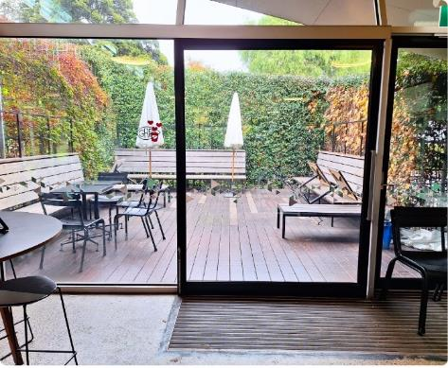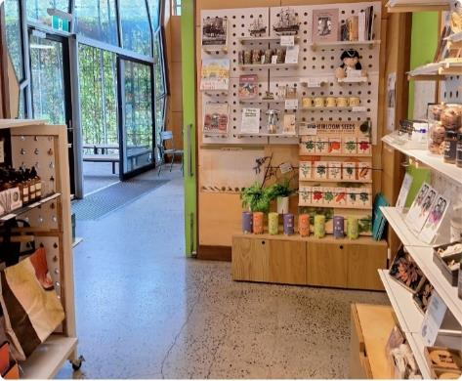The rear outdoor dining area is accessed via a manual sliding door that slides to the left as you exit the cafe. The handle has a height of 770mm to 1360mm.

# Service Counter

* Menus for the cafe are provided in standard written format. Staff can assist with the menu as required.
* KereKere Green Cafe does not take bookings and accepts card payments only.
* There is an indoor service counter and an outdoor service counter for takeaway items.

## Indoor Service Counter

* This service counter has a height of 920mm.
* There is clear floor space around the counter.
* Table service can be provided on request.
* Printed menus are available and staff can assist with menus as needed.

## Outdoor Service Counter

* The outdoor service counter is available for takeaways.
* It has a height of 1000mm with restricted knee and foot clearance.
* Takeaway items can also be ordered indoors.

## Allergens

* Gluten-free, dairy-free and vegan options are available.
* Food items are brought in off-site, therefore we cannot guarantee that there is no cross-contamination.

# a coffee shop counter with tote bags hanging on the front and pastries on display. a building with red and green ivy growing on the side of it and a service counter facing the walkway outdoors. Indoor Dining

There is clear floor space allowing forward or parallel approach to the tables.

## Furniture

* Round black pedestal tables have a height of 750mm and the height of the clearance underneath is 720mm.
* Square black pedestal tables have a height of 780mm and the height of the clearance underneath is 740mm.
* The tables have restricted knee and foot clearance.
* Black chairs without armrests have a seat height of 480mm.
* Tall roundtables have a height of 940mm and the height of the clearance underneath is 920mm.
* 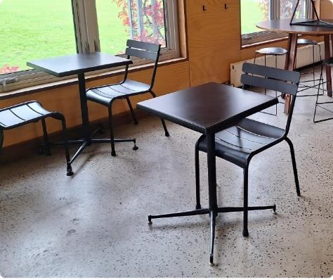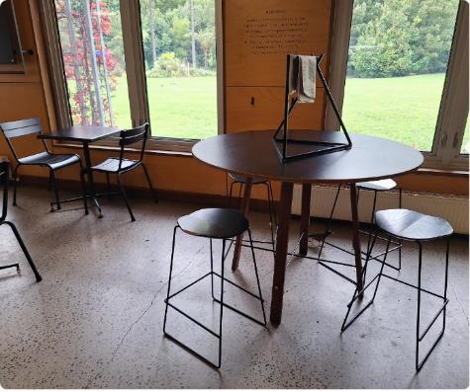Tall stools without backrests have a seat height of 670mm.

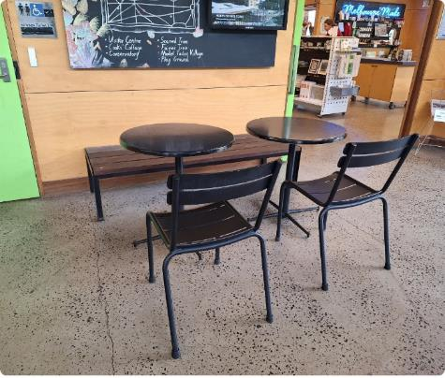

# Outdoor Dining

* Outdoor dining is available at the front of the cafe and at the rear.
* The seating area at the front of the cafe is under cover.
* There are umbrellas available at the rear of the cafe for shelter.
* There is clear floor space allowing forward or parallel approach to the tables.

## Furniture

* Square pedestal tables have a height of 780mm and the height of the clearance underneath is 740mm.
* The wooden bench seat has a seat height of 420mm.
* Black chairs without armrests have a seat height of 480mm.

# a rear patio with chairs, tables, benches and umbrellas in front of a hedge.an outdoor seating area with benches and plants in front of the cafe.Toilets

* The toilets are located between the visitor centre and the cafe.
* There are Male, Female, Ambulant and Unisex Accessible Toilets.
* There is a baby change table located in the accessible toilet.

## Accessible Toilet

* The door of the cubicle swings inward to the left when entering. The door width is 870mm.
* The lever-style door handle has a height of 1000mm. The toilet lock is a traditional style toilet indicator bolt design.
* There is a baby change table provided.
* The toilet seat height is 450mm.
* There is clear floor space to the right of the toilet. The clear floor space to the left of the toilet is 260mm.
* Rails are on the left-hand side and at the rear of the toilet with a height of 800mm.
* The basin is located at a height of 800mm.
* The hand dryer has a height of 1000mm.
* The soap dispenser is installed at 1000mm.
* 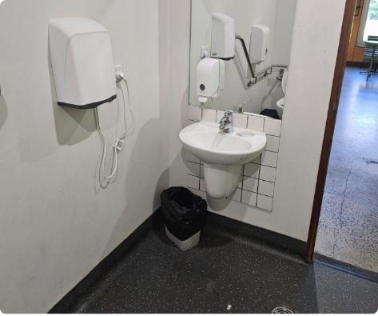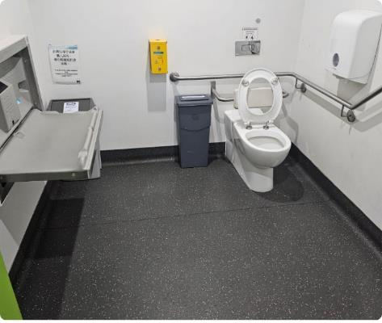There is automatic lighting in the bathroom.

# Additional Helpful Information

## Access Map

Visit the City of Melbourne [Access Map](https://www.accessmap.melbourne.vic.gov.au) for more information on accessible amenities.

## Mobility equipment hire

Visit [Travellers Aid](https://www.travellersaid.org.au) to hire various mobility equipment while you’re in Melbourne.

## Recharge points

Visit [Services for People with Disability](https://www.melbourne.vic.gov.au/community/health-support-services/accessing-melbourne/Pages/disability-services.aspx) to find your nearest recharge points for your electric scooter or wheelchair. The power points recharge the batteries for standard mobility aides, you will need to bring your own battery charger.

## Accessible and Inclusive Melbourne

Visit [Accessible and Inclusive Melbourne](https://whatson.melbourne.vic.gov.au/article/accessibility-in-melbourne) on our What's On Melbourne website to learn more about local accessible experiences. There's a great range of accessible and inclusive experiences to enjoy in Melbourne.

# Acknowledgment of Thanks

The City of Melbourne would like to acknowledge the support and assistance provided by Flare Access Pty Ltd in helping to prepare this Accessibility Guide.

This Accessibility Guide was designed and developed by Flare Access Pty Ltd. For feedback on the guide please contact the City of Melbourne.

Copyright the City of Melbourne June 2024. DISCLAIMER: Accessibility Guide developed by Flare Access. Observations made by Flare Access and additional information provided by the City of Melbourne. All materials have been compiled from information available at the time of production. They are not intended to replace professional advice including; but not limited to, access audits. All necessary care has been taken to design and produce Work(s). All measurements provided are within an approximate range. Full implementation guidelines are supplied in accordance with Work(s) in its entirety. You acknowledge and agree that you are using all services and facilities provided by the City of Melbourne at your own risk and you agree to defend, indemnify, save and hold the City of Melbourne and Flare Access Pty Ltd harmless from any and all demands, liabilities, costs, losses and claims, howsoever suffered, including but not limited to legal fees that may arise directly or indirectly from any service provided or agreed to be provided by the City of Melbourne and Flare Access Pty Ltd. You agree that this indemnification extends to all aspects of the Work(s), including but not limited to implementation and usage. The City of Melbourne and Flare Access Pty Ltd are indemnified of all claims, liability, and expenses that may arise from use of Work(s) as per usage and acceptance of these terms and conditions.