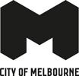

Melbourne Visitor Booth
  - Accessibility Guide
Updated April 2026

Acknowledgment of Traditional Owners
The City of Melbourne respectfully acknowledges the Traditional Owners of the land we govern, the Wurundjeri Woi-wurrung and Bunurong / Boon Wurrung peoples of the Kulin Nation and pays respect to their Elders past and present. We acknowledge and honour the unbroken spiritual, cultural and political connection they have maintained to this unique place for more than 2000 generations.
We accept the invitation in the Uluru Statement from the Heart and are committed to walking together to build a better future.

Contact Us
Address: Bourke Street Mall, Melbourne 3000
Phone: 03 9658 9658 (Monday to Friday only)
Email visitor@melbourne.vic.gov.au
Website: https://whatson.melbourne.vic.gov.au/things-to-do/melbourne-visitor-booth

Hours of Operation
Open daily 10am to 5pm.

Contents
Acknowledgment of Traditional Owners 2
Contact Us 2
Hours of Operation 2
Welcome 4
Access At a Glance 4
Our Staff 4
Social Script 5
What To Expect 5
Getting Here 6
Travel by tram 6
Travel by train 6
Flinders Street Station 6
Melbourne Central Station 6
Town Hall Station 7
Travel by car 8
On street parking 8
Off street parking 8
Arrival 8
Entrance 8
Retail 9
Booking Service 9
Customer Feedback 10
Peak Periods 10
Virtual Visitor Hub 10
Consultation 10
Availability 10
Bookings 11
Communication and Information 11
Sounds 11
Temperature Control 12
Lighting and Visual Stimulus 12
Scents 12
Additional Helpful Information 12
Access Map 12
Mobility equipment hire 12
Recharge points 12
Accessible and Inclusive Melbourne 12
Acknowledgement of Thanks 13

Welcome
Located in the Bourke Street Mall, the Melbourne Visitor Booth is your go-to spot for maps, insider tips and recommendations on shopping, attractions, public transport and events.
Our friendly staff and volunteers are here to help you make the most of your time in Melbourne, whether you are looking for the best places to eat, shop or explore.

Access At a Glance
- Accessible Parking
- Step Free Access
- Communication Boards

Our Staff
- We have a diverse, friendly team of staff and volunteers available to share local knowledge and personal insights about Melbourne and some information on regional Victoria.
- Our volunteers can provide advice on things to do and help you create a customised itinerary.
- Staff and volunteers are easily recognisable as they wear name badges and red shirts with black trousers or skirts.
- Our staff and volunteers participate in an E-learning module on accessibility and are trained in the hidden disability Sunflower Scheme. They are happy for you to approach them and ask questions.
- Some of our staff and volunteers are multi-lingual and provide assistance in other languages as needed. These staff and volunteers wear 'language badges' so they are easily identified by visitors who need assistance in their own language.
We look forward to welcoming you to the booth and helping you explore all that Melbourne has to offer, with some additional information on regional Victoria to inspire your travels.
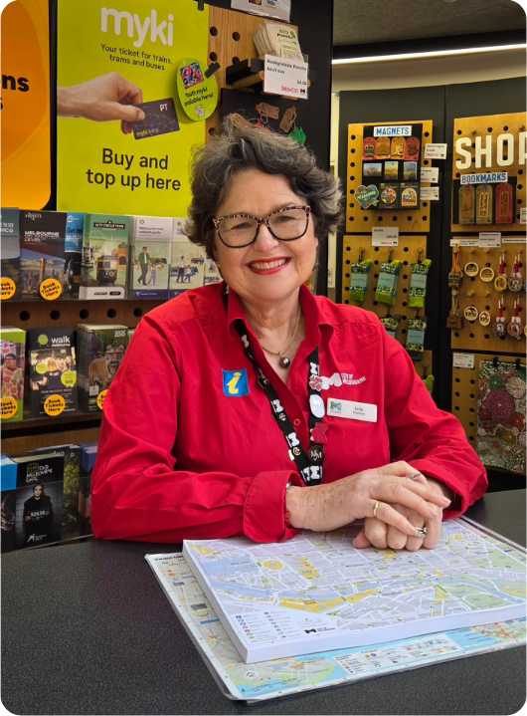

Social Script
- I am going to visit the Melbourne Visitor Booth. It is a place where I can get help and information about Melbourne and some information on regional Victoria.
- When I arrive, I might see other people there at the counter, also looking for information.
- Friendly staff and volunteers at the booth can help me, they know a lot about things to do and places to see and if I need help planning my visit, they can give me advice and help me find interesting places to visit.
- Staff and volunteers can give me maps and brochures.
- I can purchase souvenirs and gifts made by local businesses and I can purchase and top up myki.
- There are iPads where staff and volunteers can find more information. The staff and volunteers use the iPads to explore different attractions and events.
- It is okay to feel excited or a little nervous. The staff and volunteers are there to help me feel comfortable and answer any questions I have.
- I can use the information I get to plan my day in Melbourne. I might learn about special events, museums, parks and more.
- When I am ready to leave, I will have lots of information to help me enjoy my visit. I can always come back if I have more questions or need more help.

What To Expect
- When you arrive, friendly staff and volunteers will greet you and offer assistance.
- The booth is designed as an open service counter positioned directly along the pedestrian path.
- There is no queuing system to talk with the staff and volunteers as it is based on a first-come, first-served basis
- You may choose to browse the information provided or receive assistance from staff and volunteers.
- There is plenty of information about what’s on in Melbourne and some information on regional Victoria including:
- How to get around and public transport
- Free walking maps of the city’s street art, laneways and arcades
- Guides, brochures and maps
- Locally sourced products and gifts are available for purchase and staff can bring products and gifts to the counter to view.
- New myki cards can be purchased and Myki top-up is available including myki Money and myki Pass.
- There is level access approaching the booth and adequate clear floor space for mobility aids.
- Nearest accessible toilets are located in Melbourne Walk and Myer Melbourne.

Getting Here

Travel by tram
- The nearest tram stop is Bourke Street Mall stop 5, with routes 86 and 96. The tram stop is approximately 20 metres from the Melbourne Visitor Booth.
- The next closest tram stop is Bourke Street Mall/Elizabeth Street stop 3, with routes 19, 57 and 59. The tram stop is approximately 100 metres from the Melbourne Visitor Booth.
- The tram stop for routes 1, 3, 5, 6, 16, 64, 67 and 72 is located at Bourke Street Mall/Swanston Street stop 10, approximately 190 metres from the Melbourne Visitor Booth.
- Low-floor trams operate on routes 5, 6, 16, 19, 72, 86 and 96. Check Public Transport Victoria for low-floor tram timetables.
- These stops are within the Free Tram Zone.
- A step-free route is available from these tram stops.
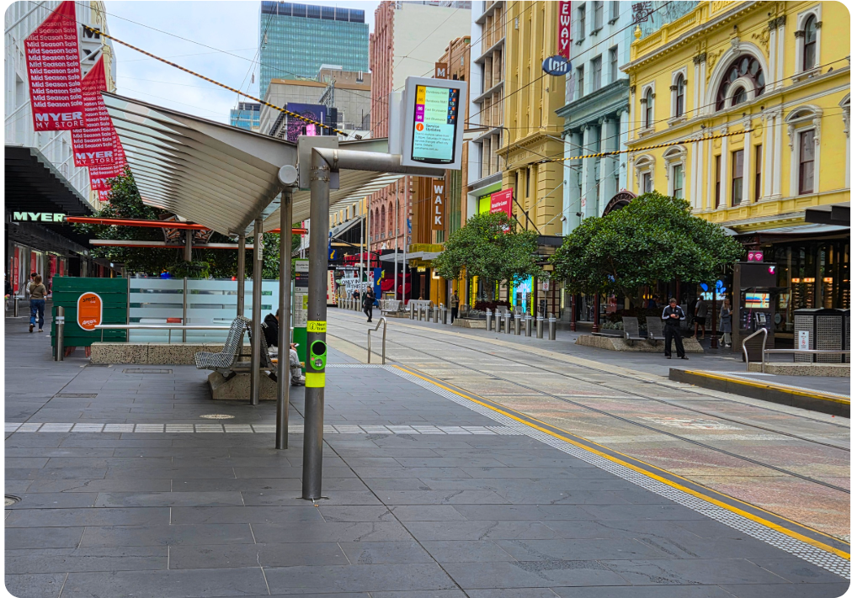

Travel by train

Flinders Street Station
- Approximately 650 metres from the Melbourne Visitor Booth.
- This station is accessible and a step-free route is available.

Melbourne Central Station
- Approximately 450 metres from the Melbourne Visitor Booth.
- This station is accessible and a step-free route is available.

Town Hall Station
- Approximately 450 metres from the Melbourne Visitor Booth.
- This station is accessible and a step-free route is available.
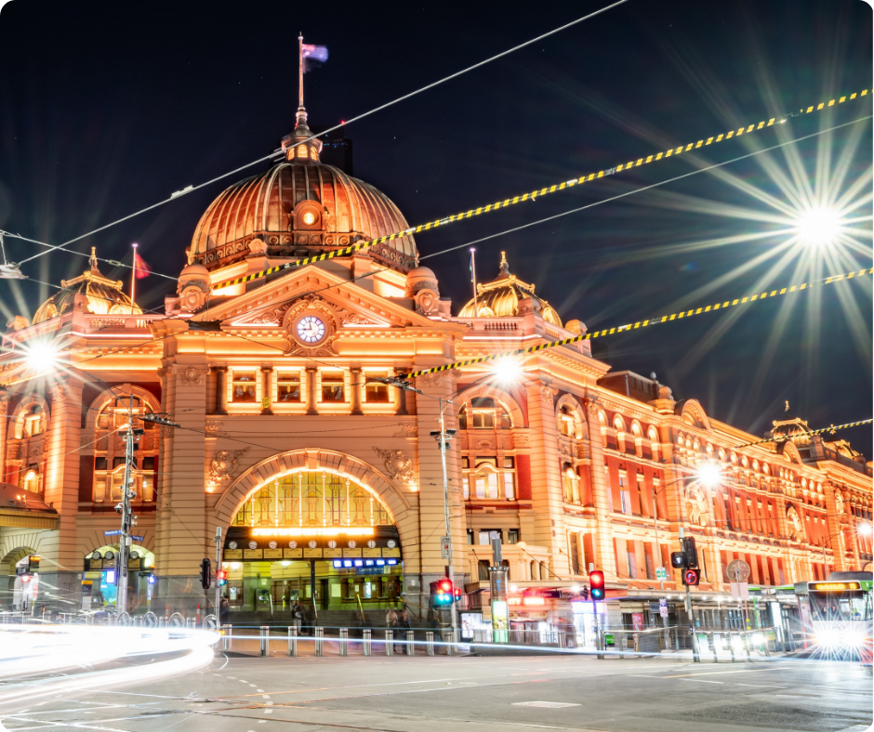

Travel by car
- The Melbourne Visitor Booth is located within Bourke Street Mall, a pedestrian and tram-only zone. Private vehicles cannot access or park within the mall.

On street parking
- There is limited, time-restricted street parking on Elizabeth Street, including accessible parking spaces.
- Visit Parking for people with disability to find and navigate to parking spaces reserved for people with disability: https://www.melbourne.vic.gov.au/parking-people-disability

Off street parking
- The nearest off-street parking is at Galleria Melbourne, 131 Elizabeth Street.
- The parking is approximately 100 metres from the Melbourne Visitor Booth.
- Visit the City of Melbourne website for more information on nearby car parks: City of Melbourne off-street parking - Google My Maps

Arrival
- The Melbourne Visitor Booth is located at street level along a wide pedestrian pathway with a generally flat and even paved surface.
- The approach provides good circulation space, allowing visitors to move comfortably along the path and approach the service counter.
- Service animals are welcome at the Melbourne Visitor Booth.

Entrance
- Clear signage indicates the front of the booth.
- The open frontage of the booth provides clear visual access to the service counter from multiple directions along the footpath.
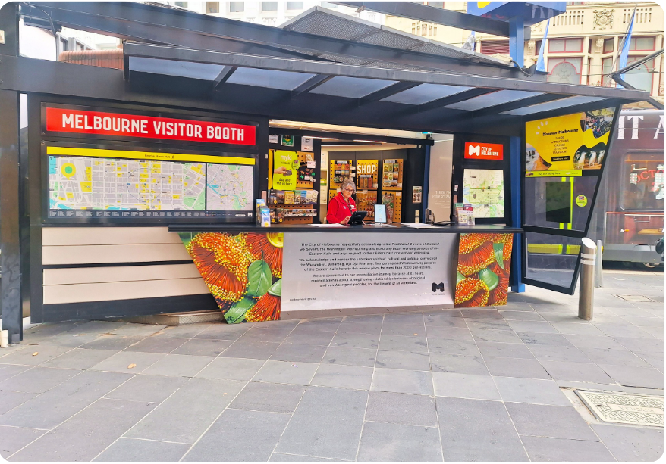
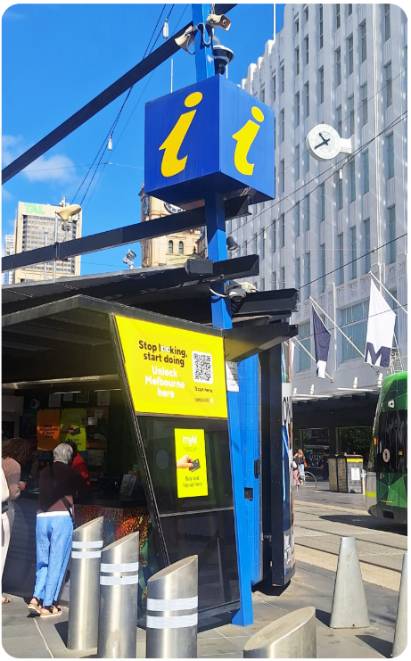

Retail
- Retail items are displayed on pegboard panels mounted along the back wall of the booth.
- Products featuring a variety of locally sourced products and gifts such as magnets, postcards, bookmarks, socks and small souvenirs are hung on hooks across the boards.
- Staff and volunteers can take items from the display and show them to visitors if needed.
- We accept contactless payment only.
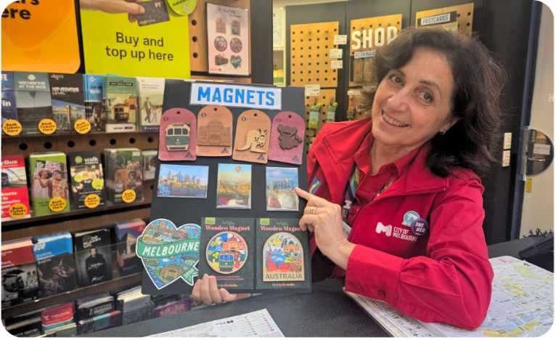
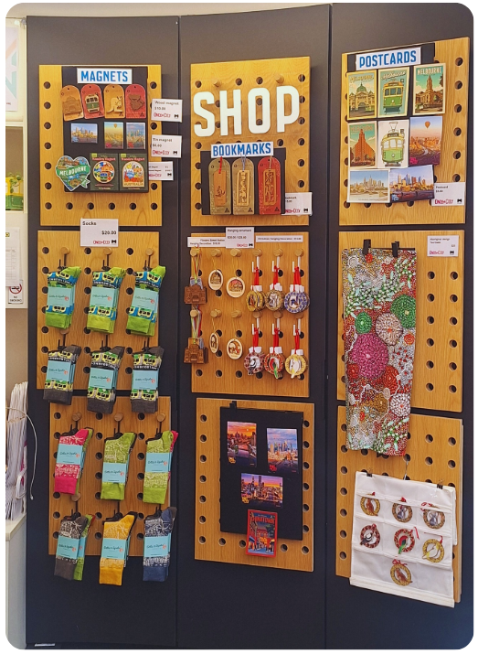
Visitor Assistance
- The Melbourne Visitor Booth operates from an open service counter facing Bourke Street Mall. The service counter height is approximately 1130mm.
- Staff and volunteers can assist visitors from street level if needed.
- Staff and volunteers can provide information about things to do in Melbourne and some information on regional Victoria, including:
  - Support navigating booking processes.
  - Information about booking agencies for local events and experiences.
  - Details on how visitors can access support services, such as personal assistants or guides and any partnerships with local disability services.
  - Support to connect with Travellers Aid.
  - Your itinerary, guides and maps, or information discussed can be shared with you by email on request.
  - For further assistance outside our opening hours of Monday to Sunday 10am to 5pm please contact us at visitor@melbourne.vic.gov.au

Booking Service
- Experience Oz operate a tour booking service at the service counter
- A friendly booking agent is available Thursday to Monday from 11am to 3pm stationed behind the counter, they can assist you with booking attractions and day trips around Melbourne and Victoria.
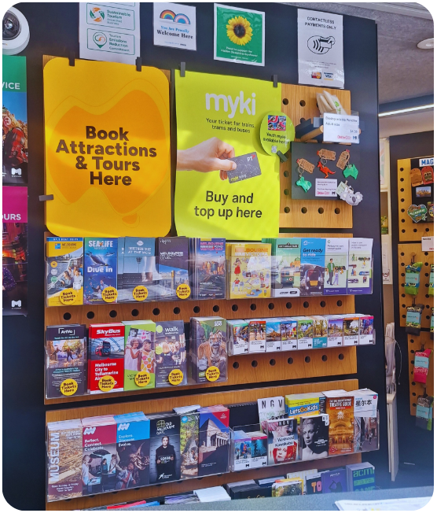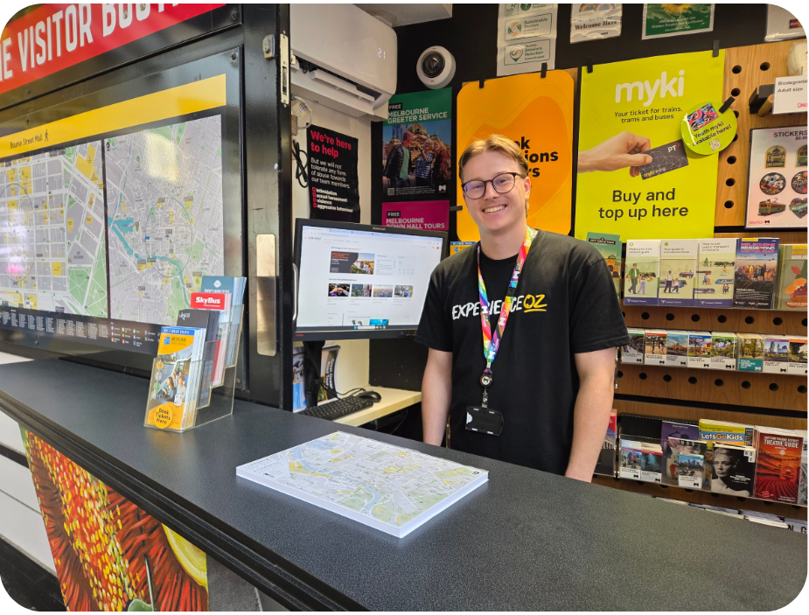

Customer Feedback
- We invite feedback on your experience when visiting the Melbourne Visitor Booth.
- You can provide feedback via the portable Feedback Tablet which is located on the service counter. Staff and volunteers can assist with this as required.

Peak Periods
- Peak days and times at the booth vary depending on the season, school holidays and what other events are happening in the city.
- In general Monday to Sunday 11am to 2pm are the busiest.

Virtual Visitor Hub
Can't make it in to a visitor centre? Book in a time with one of our dedicated tourism staff to help plan your next trip to Melbourne or regional Victoria.

Consultation
The virtual visitor consultation offers:
- Local knowledge and personal insights
- Customised itineraries
- Access to online maps and walks
- Advice on things to do and how to get around
- Consultations run for up to 20 minutes and can be held by phone or online via Microsoft Teams. Phone consultations are available to Australian numbers only.

Availability
- Consultations are available Monday to Sunday from 10.30am to 4.30pm.

Bookings
- Complete the form to request a virtual visitor consultation. Please allow one business day for bookings to be confirmed.
- Alternatively, email visitor@melbourne.vic.gov.au with your tourism enquiries.
- https://whatson.melbourne.vic.gov.au/visitor-info/virtual-visitor-hub

Communication and Information
- Our staff and volunteers deliver information verbally.
- There are information signs throughout the booth and staff can assist with reading and sharing this information.
- Information is provided in digital and printed formats.
- Most printed and digital material is produced by third parties. Staff will assist with providing this in alternative formats where possible; however, we have limited control over the accessibility of this material.
- Most material is available in digital alternatives and can be used with the magnification feature of the tablet.
- Posters with a QR code on Accessible and Inclusive experiences in Melbourne are available with further information found on https://whatson.melbourne.vic.gov.au/article/accessibility-in-melbourne.
- Communication boards are available on request.
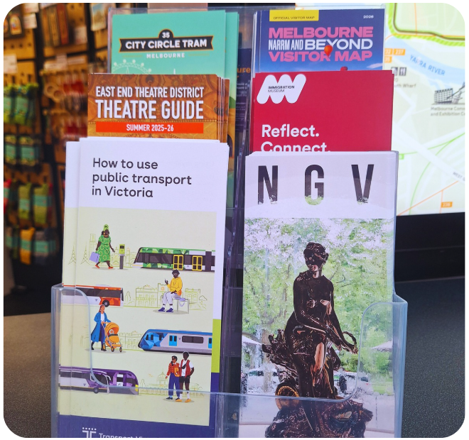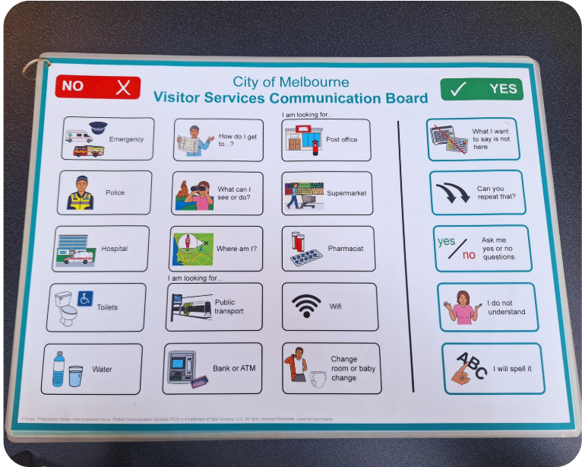

Sounds
- The Melbourne Visitor Booth is located in a busy city street environment. Visitors can expect typical city sounds, including pedestrians walking past, nearby conversations and general street activity.
- Trams regularly pass along Bourke Street Mall and can be heard when approaching or stopping nearby.
- Emergency vehicles such as ambulances, police cars and fire trucks occasionally pass through the area and may use sirens.
- Music may be heard echoing from nearby shops and buskers.
- At times, the sound environment may become busy or noisy due to the combination of pedestrian activity and passing trams.

Temperature Control
- The Melbourne Visitor Booth service counter is located outdoors and is open to the surrounding street environment. Because of this, the temperature inside the booth may be similar to the outdoor temperature.
- A roof structure provides some shelter from sun and rain as the booth is not fully enclosed.
- On hot, cold or windy days, visitors may experience outdoor weather conditions while speaking with staff at the counter.

Lighting and Visual Stimulus
- The Melbourne Visitor Booth is located outdoors and is primarily lit by natural daylight.
- Additional lighting is used inside the booth to illuminate information displays.
- Because the booth is located on a busy city street, there may be a high level of visual activity. Visitors may see pedestrians walking past, passing trams, nearby traffic and movement in surrounding shops and buildings.

Scents
- Visitors may notice a range of everyday city smells.
- These may include food smells from nearby cafés and restaurants, vehicle exhaust from passing traffic and occasional construction or street maintenance smells.
- As the booth is open to the surrounding environment, scents can change throughout the day depending on weather, nearby businesses and street activity.
- At certain times of the year, visitors may also notice outdoor pollen from nearby trees or plants.
- Hand Sanitiser is available on request at the service counter

Additional Helpful Information

Access Map
Visit the City of Melbourne Access Map for more information on accessible amenities.

Mobility equipment hire
Visit Travellers Aid to hire various mobility equipment while you’re in Melbourne.

Recharge points
Visit Services for People with Disability to find your nearest recharge points for your electric scooter or wheelchair. The power points recharge the batteries for standard mobility aides, you will need to bring your own battery charger.

Accessible and Inclusive Melbourne
Visit Accessible and Inclusive Melbourne on our What's On Melbourne website to learn more about local accessible experiences. There's a great range of accessible and inclusive experiences to enjoy in Melbourne.

Acknowledgement of Thanks
The City of Melbourne would like to acknowledge the support and assistance provided by Flare Access Pty Ltd in helping to prepare this Accessibility Guide.
This Accessibility Guide was designed and developed by Flare Access Pty Ltd. For feedback on the guide please contact the City of Melbourne.
Copyright the City of Melbourne April 2026. DISCLAIMER: Accessibility Guide developed by Flare Access. Observations made by Flare Access and additional information provided by the City of Melbourne. All materials have been compiled from information available at the time of production. They are not intended to replace professional advice including; but not limited to, access audits. All necessary care has been taken to design and produce Work(s). All measurements provided are within an approximate range. Full implementation guidelines are supplied in accordance with Work(s) in its entirety. You acknowledge and agree that you are using all services and facilities provided by the City of Melbourne at your own risk and you agree to defend, indemnify, save and hold the City of Melbourne and Flare Access Pty Ltd harmless from any and all demands, liabilities, costs, losses and claims, howsoever suffered, including but not limited to legal fees that may arise directly or indirectly from any service provided or agreed to be provided by the City of Melbourne and Flare Access Pty Ltd. You agree that this indemnification extends to all aspects of the Work(s), including but not limited to implementation and usage. The City of Melbourne and Flare Access Pty Ltd are indemnified of all claims, liability, and expenses that may arise from use of Work(s) as per usage and acceptance of these terms and conditions.

