

Melbourne Town Hall Tours
Accessibility Guide
Updated June 2024

Acknowledgment of Traditional Owners
The City of Melbourne respectfully acknowledges the Traditional Owners of the land we govern, the Wurundjeri Woi-wurrung and Bunurong / Boon Wurrung peoples of the Kulin Nation and pays respect to their Elders past and present. We acknowledge and honour the unbroken spiritual, cultural and political connection they have maintained to this unique place for more than 2000 generations.
We accept the invitation in the Uluru Statement from the Heart and are committed to walking together to build a better future.

Contact Us
Address: Melbourne Town Hall 90-130 Swanston Street, Melbourne 3000
Phone: 03 9658 9658
Email: townhalltour@melbourne.vic.gov.au
Website: www.melbourne.vic.gov.au/townhalltours

Welcome 5
Access At A Glance 5
Tour Guides 5
Social Script 6
What To Expect 6
Duration 6
Rooms Visited 6
Join your Guide 6
Photography 7
Rest Breaks 7
Accessible Facilities 7
Hours of Operation 7
Getting Here 8
Travel by tram 8
Travel by train 8
Flinders Street Station 8
Travel by car 9
On street parking 9
Off street parking 9
Arrival 9
Meeting Point 9
Main Entrance 10
Security Concierge 10
What to expect 10
Security Gates 11
Beginning the Tour 11
The Lift 12
During the Tour 12
Things You Will See 13
Council Chambers 13
Yarra Room 13
Royal Banners 13
Melbourne Room 14
Portico Room 14
Portico Balcony 14
Main Hall Balcony 15
Adult Change Room 17
Signage and Information 19
Sounds 19
Lighting and Visual Stimulus 19
Scents 19
Additional helpful information 20
Access Map 20
Mobility equipment hire 20
Recharge points 20
Acknowledgment of thanks 21

Welcome
Melbourne Town Hall is at the heart of the city’s cultural and civic activity. Learn about the building's unique history as you visit the Grand Council Chambers and stand in rooms once visited by royalty. You’ll even get to stand on the Portico Balcony where the Beatles stood in 1964, waving to thousands of screaming fans below.
The new Melbourne Town Hall Commons holds a focus on a collection of contemporary work by Aboriginal artists, which gives an Aboriginal voice to the fresh and democratic meeting place for Melbourne.

Access At A Glance
- Accessible Toilet
- Accessible Parking
- Accessible Adult Change with Hoist
- Step Free Access
- Baby Changing Table
- Portable Assistive Listening Device

Tour Guides
- We have a diverse and friendly team of guides available to lead your tour.
- Tour guides wear casual clothing and name badges with large, clear text.
- Guides also wear colourful City of Melbourne lanyards, which help you easily recognise them as official tour guides.
- After you go through security, your tour guide will meet you and will be with you throughout the tour.
- Guides will share historical insights about Melbourne Town Hall, introduce significant figures and highlight key events in the city's history.
- Our guides are trained on the Sunflower Scheme and are happy for you to ask questions throughout the tour.
- Please ask for permission before you take photos of your guide.
We look forward to welcoming you on the tour and exploring the rich history of Melbourne Town Hall together!
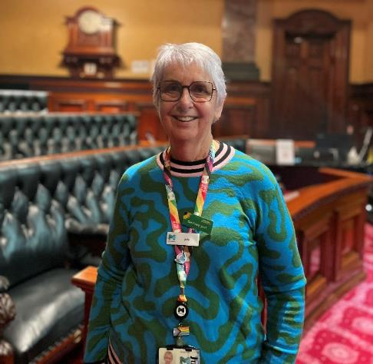

Social Script
- During the Melbourne Town Hall tour, I will hear all about interesting historical facts about Melbourne Town Hall and the City of Melbourne.
- Before I start the tour, I will go through security. My bag will be scanned using an x-ray machine and I will sign in using a QR code. If I need help, a friendly staff member at the front desk will be there to assist me.
- A Tour Guide will take me to different rooms in Melbourne Town Hall and share stories and information. There might be other people joining me who are also on the tour.
- My Tour Guide wears casual clothing, a name badge and a lanyard around their neck so they'll be easy to recognise.
- They know a lot about the Melbourne Town Hall and I can ask them any questions I have. I can also speak with other people in the group if I want to.
- I can choose to explore the rooms we visit, and there will be lots of interesting things to see in each room. If I need a break, I can let my Tour Guide know. There are places to sit and relax if I need to take a breather.
- I might need to wait my turn to see items on display, but there will be plenty of time to see everything I want to.
- Some items can be touched, and others can't. I'll ask my Tour Guide if I'm not sure about touching something.
- I had a really good time on the Melbourne Town Hall tour. I learned a lot about the Town Hall and the city's history.

What To Expect

Duration
- The tour lasts approximately one hour and is predominantly indoors.

Rooms Visited
- You will visit approximately eight rooms in Melbourne Town Hall, spending around ten minutes in each.
- Sometimes rooms are not available due to events or bookings. Room availability is subject to change and the tour itinerary may change accordingly. We will let you know about this at the beginning of the tour.
- Rooms you may visit include:
  - Town Hall Commons
  - Council Chambers
  - Yarra Room
  - Portico Room and Balcony
  - Melbourne Room
  - Main Hall
- This tour does not include a tour of the Art and Heritage Collection.

Join your Guide
- Your Tour Guide will meet you after you have cleared security. There may be others joining you on the tour. Everyone is there to learn and enjoy the history of Melbourne Town Hall.
- You will be guided through various rooms and areas of Melbourne Town Hall with your Tour Guide sharing stories and information at different points.

Photography
- You can take photos and ask questions throughout the tour.
- Photos are permitted in the rooms only, not in the corridors.
- Some areas that you visit are shared with staff working at Melbourne Town Hall. We ask that you respect their privacy and avoid taking their photos.

Rest Breaks
- Many rooms have seating available for you to take a seated rest break as needed.

Accessible Facilities
- There is step-free access throughout the tour. There are slight inclines and declines when accessing different rooms.
- A wheelchair is available for use during the tour. Please book this in advance.
- Accessible toilets and Changing Places are available on the ground floor.

Hours of Operation
Monday 11am - 12pm
1pm - 2pm
Tuesday Closed
Wednesday 11am - 12pm
1pm - 2pm
Thursday 11am - 12pm
1pm - 2pm
Friday 11am - 12pm
1pm - 2pm
Saturday Closed
Sunday Closed
We do not operate on public holidays.

Getting Here

Travel by tram
- The nearest tram stop is Melbourne Town Hall/Collins Street #6 with routes 109, 11, 12, 48. The tram stop is approximately 95m from the Melbourne Town Hall entry.
- The next closest tram stop is City Square/Swanston Street with routes 1, 16, 3, 5, 6, 64, 67, 72. The tram stop is approximately 105m from the Melbourne Town Hall entry.
- Tram routes 109, 11, 48, 5, 6, and 16 all offer low-floor tram options. Check Public Transport Victoria for the times of the Low-floor options.
- These stops are included in the free tram zone.
- A step-free route is available from the tram stops.
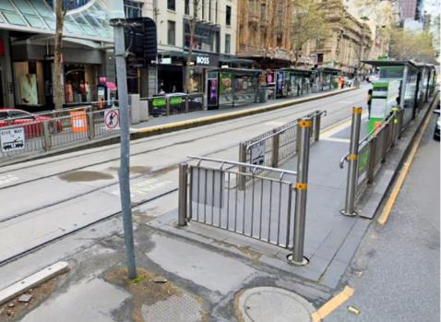

Travel by train

Flinders Street Station
- This station has accessible station access.
- The station is approximately 300m from the Melbourne Town Hall entry.
- A step-free route is available from the train station.
- Melbourne Central Station
- This station has accessible station access.
- The station is approximately 550m from the Melbourne Town Hall entry.
- A step-free route is available from the train station.
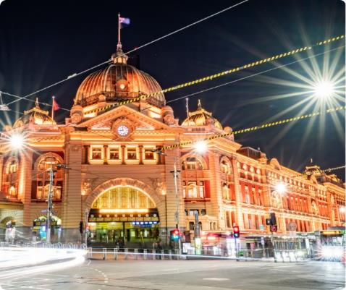

Travel by car

On street parking
- There is limited time-restricted street parking on Collins Street including accessible parking.
- Once you are on the footpath, there is a continuous accessible path of travel to the entry. Access to the footpath is via the nearby traffic lights where there is a kerb ramp.
- Visit Parking for people with disability to find and navigate to parking spaces reserved for people with disability.

Off street parking
- The nearest paid off- street parking is 233-239 Collins Street.
- This parking is approximately 100m from the Melbourne Town Hall entrance.
- Please visit the City of Melbourne’s Off Street Parking for more information on car park locations and Council operated car parks.

Arrival

Meeting Point
- The meeting point for the tour is located inside the Administration Building door, Melbourne Town Hall, 90-130 Swanston Street.
- The path to the main entrance is paved.
- There is step-free access from the frontage to the main entrance.
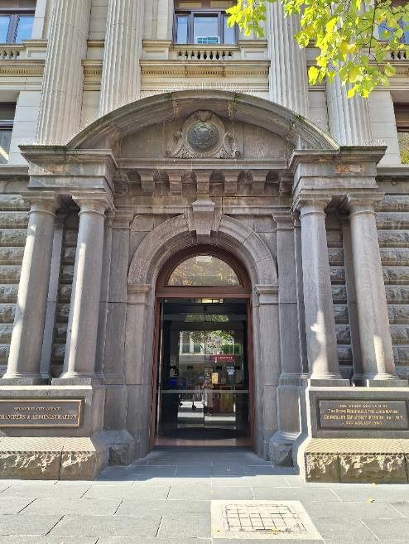

Main Entrance
- There is a clear and step-free path of travel to the main entrance.
- Automatic glass sliding doors with visual markings open to the Concierge.
- The clear door width is greater than 1000mm.
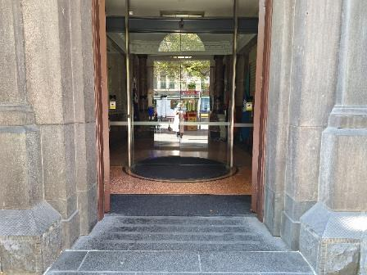

Security Concierge

What to expect
- Arrive 15 minutes prior to your tour to allow time to go through security.
- You will be asked to pass your personal belongings through an x-ray machine.
- The security process is flexible and may be adapted to suit your access needs.
- If you are seated in a wheelchair, security will conduct a visual security assessment of your wheelchair.
- If you have large items such as prams, luggage, or large backpacks, you will be asked to leave them in the cloakroom. There is a limited cloak area.
- You will be asked to show your photo identification and sign in using a QR code at the Concierge using a tablet, staff can assist you as necessary.
- A visitor pass and lanyard will be provided that you can wear around your neck. This will be returned to the Concierge at the end of the tour.
- The service counter has a height of 850mm and there is clear floor space in this area.

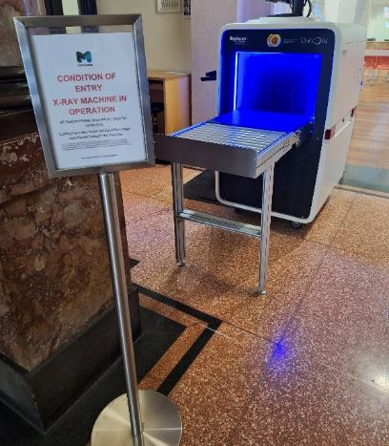

Security Gates
- After the Town Hall Commons, the first room you visit on the tour, you will pass through security gates and again on Level 2.
- You will scan your visitor pass and the doors will open. Staff can assist you as needed.
- The gate has glass doors that will retract as you enter.
- The width of the gate is 930mm.
- After signing in, you will enter the Melbourne Town Hall Commons through automatic glass sliding doors that have a width greater than 1000mm.

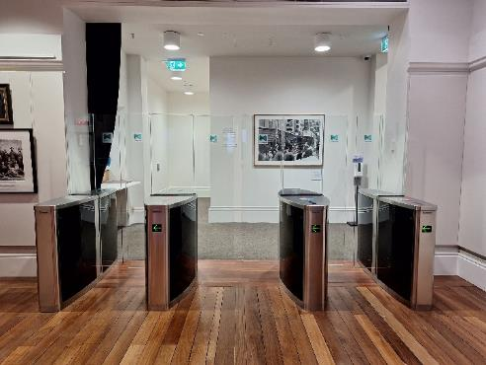

Beginning the Tour
- You will meet your Tour Guide in the Melbourne Town Hall Commons.
- Seating is available in this room as you wait, with firm chairs without armrests.
- There may be other people waiting in the Town Hall Commons to join the same tour.
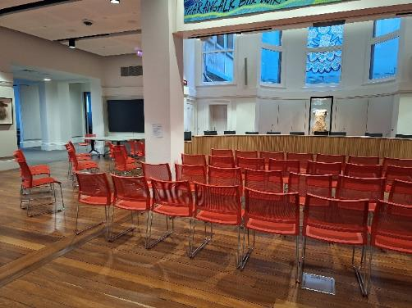

The Lift
- Your Tour Guide will accompany you to level 2 in the lift and will assist with directions.
- Braille and tactile indicators are available on the lift buttons.
- The lift has dimensions of 1740mm x 1220mm.
- A handrail is available in the lift.
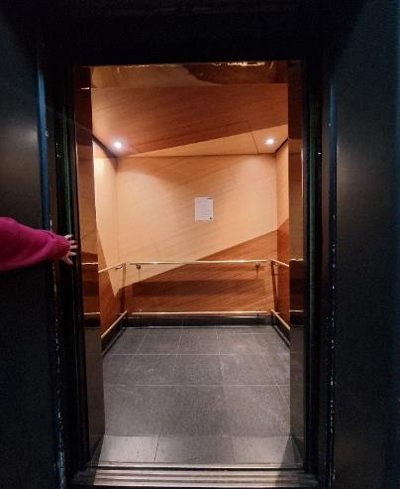

During the Tour
- There is step-free access throughout the tour.
- Doors have a clear width greater than 850mm.
- There is adequate clear floor space throughout the tour.
- The flooring throughout the tour is mostly low to medium-pile carpet.
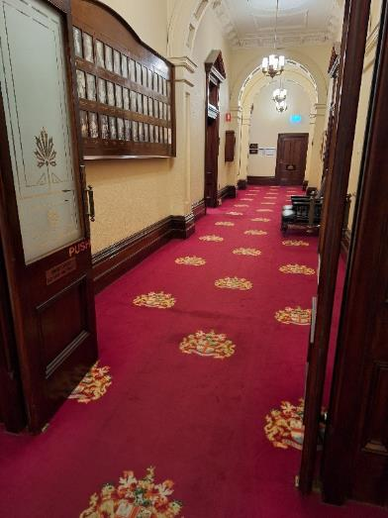

Things You Will See

Council Chambers
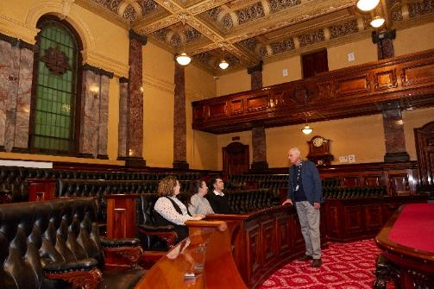

Yarra Room
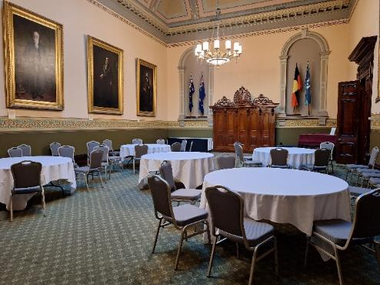

Royal Banners
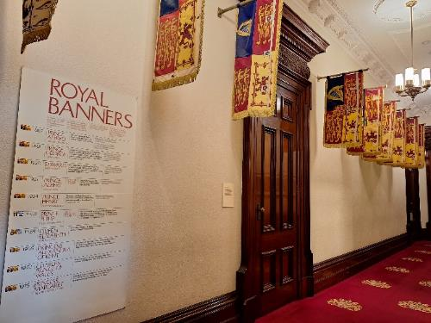

Melbourne Room
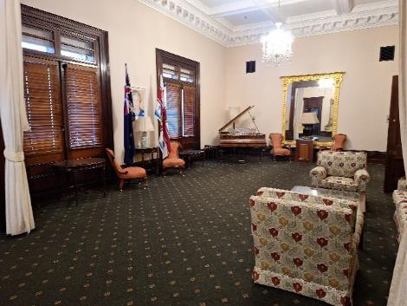

Portico Room
- The Portico room offers a low sensory environment if required. Please speak with your tour guide if you would like a low-sensory break during the tour.
- The lighting in this room can be adjusted up or down on request.
- Temperature can be controlled in this room on request.
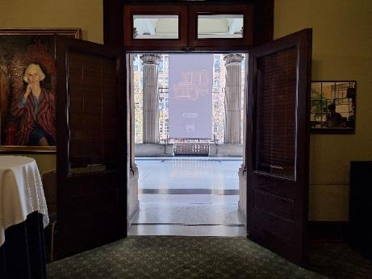

Portico Balcony
- There is a slight gradient down to wide double doors to access the Balcony.

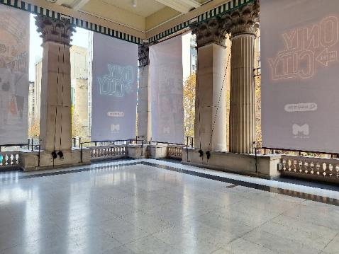

Main Hall Balcony
- The viewing of the Main Hall Balcony can be accessed up eight stairs.
- Handrails have a height of 960mm and are positioned on the right and left sides.
- There is a slight gradient down to the doors of the Main Hall Balcony.
- Step-free access to the Main Hall is also available and you will view the Main Hall from the ground floor.
- Here you will get to view and at times hear the Melbourne Town Hall Grand Organ. You can see more details on the City of Melbourne website
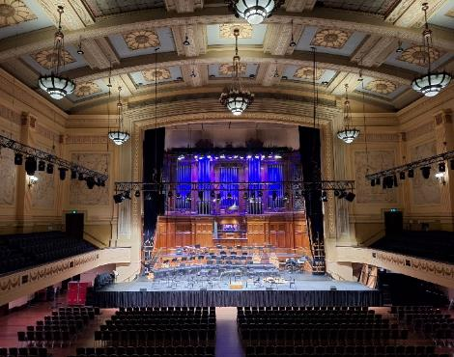
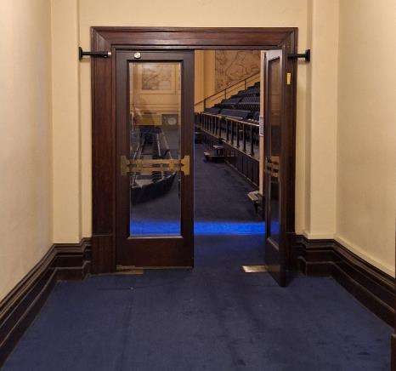
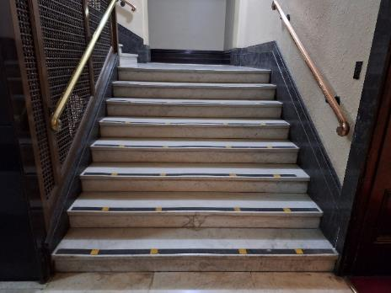
Seating and Rest Areas
- Throughout the tour, you will have opportunities to rest and take a break if needed.
- If you would like a break during the tour, please inform your Tour Guide and they will find the nearest place to take a break.
- There are various seating options with and without armrests.
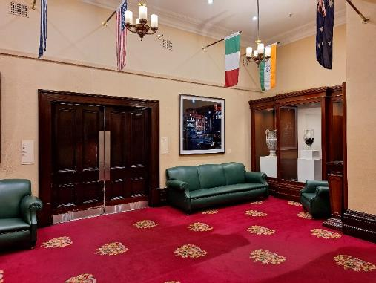

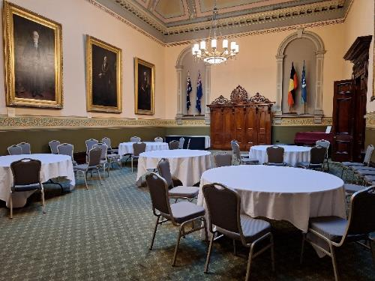

Adult Change Room
- Location: Ground floor, Melbourne Town Hall
- Accessed via an MLAK key which is available from Security.
- You will have the opportunity to use the facilities before and after the tour, there is limited opportunity to visit the facilities during the tour.
- There is an adult changing facility with a ceiling hoist.
- A shower with a handheld shower hose and fold-down shower chair.
- Privacy screen.
- An accessible toilet with drop-down rails on the right and left side.
- A manual wheelchair is available for use.
- Visit Getting Around Melbourne to find more Adult Change rooms in the city.
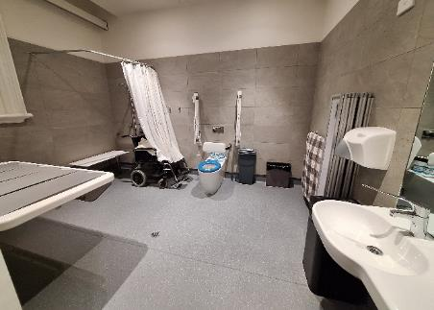
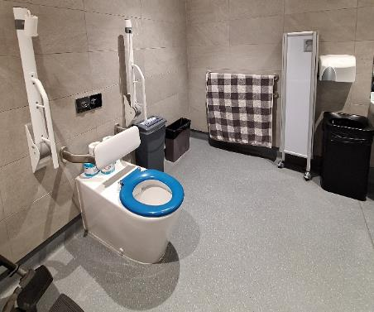
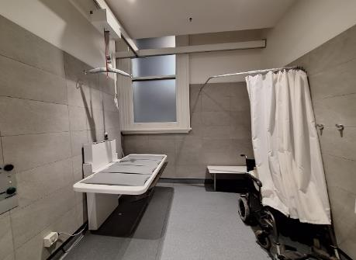
RHS Accessible Toilet
- Location: Ground floor, Melbourne Town Hall
- You will have the opportunity to use the facilities before and after the tour, there is limited opportunity to visit the facilities during the tour.
- The manual door is inswinging to the left and has a clear width of 860mm. The door to enter the toilet has a D-shaped lever handle with a height of 1000mm. There is a long lever lock.
- The toilet has a height of 450mm. The clearance on the right side of the toilet is 270mm and on the left it is open. Grab rails are located on the right side and rear of the toilet and are positioned with a height of 800mm.
- The basin has a height of 1100mm with a lever-style tap. The soap dispenser has a height of 1000mm. The hand dryer is positioned next to the basin with a height of 1000mm.
- Lighting is automatic.
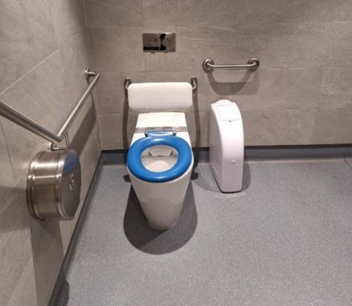
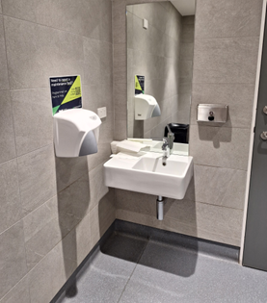

Signage and Information
- Our Tour Guides deliver information verbally.
- There are informational signs throughout the tour and staff can assist with reading and sharing this information.
- A portable Assistive Listening Device is available. Please contact us in advance if you would like to book this device for your tour.
- Signage with Braille indicates key areas including the toilets and lift.
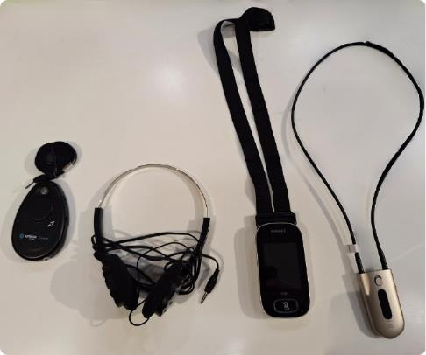

Sounds
- There are typically few sounds in the Melbourne Town Hall Tour besides the Tour Guide and other guests.
- The volume of other guests will depend on the number of other people enjoying the tour on the day.
- In some areas, you may hear gentle traffic sounds such as when you are visiting the Portico Balcony.
- There may be noise from bump-in and bump-out activities associated with events held at the Melbourne Town Hall.
- You may hear performers rehearsing in the Main Hall.
- If it gets loud or if you would like some quiet during the tour, you can wear your personal headphones.

Lighting and Visual Stimulus
- There are TV screens in some areas of the tour.
- Lighting varies throughout the tour from 50 lux indoors to 800 lux in natural lighting outdoors.
- On average the lux is approximately 260 lux. Lighting is mostly consistent throughout the tour.
- There is minimal glare throughout the tour.

Scents
- You may occasionally smell the food of Council staff members.
- Mildly scented hand wash is located in the bathrooms.
- Hand sanitiser may be located in the bathrooms and other rooms that you visit.
- Air fresheners may be located in the bathrooms and may be used in other rooms that you visit.

Additional helpful information

Access Map
Visit the City of Melbourne Access Map for more information on accessible amenities.

Mobility equipment hire
Visit Travellers Aid to hire various mobility equipment while you’re in Melbourne.

Recharge points
Visit Services for People with Disability to find your nearest recharge points for your electric scooter or wheelchair. The power points recharge the batteries for standard mobility aides, you will need to bring your own battery charger.

Acknowledgment of thanks
The City of Melbourne would like to acknowledge the support and assistance provided by Flare Access Pty Ltd in helping to prepare this Accessibility Guide.

Copyright the City of Melbourne May 2024. DISCLAIMER: Accessibility Guide developed by Flare Access. Observations made by Flare Access and additional information provided by the City of Melbourne. All materials have been compiled from information available at the time of production. They are not intended to replace professional advice including; but not limited to, access audits. All necessary care has been taken to design and produce Work(s). All measurements provided are within an approximate range. Full implementation guidelines are supplied in accordance with Work(s) in its entirety. You acknowledge and agree that you are using all services and facilities provided by the City of Melbourne at your own risk and you agree to defend, indemnify, save and hold the City of Melbourne and Flare Access Pty Ltd harmless from any and all demands, liabilities, costs, losses and claims, howsoever suffered, including but not limited to legal fees that may arise directly or indirectly from any service provided or agreed to be provided by the City of Melbourne and Flare Access Pty Ltd. You agree that this indemnification extends to all aspects of the Work(s), including but not limited to implementation and usage. The City of Melbourne and Flare Access Pty Ltd are indemnified of all claims, liability, and expenses that may arise from use of Work(s) as per usage and acceptance of these terms and conditions.

