

Cooks’ Cottage
  - Accessibility Guide
Updated June 2024

Acknowledgment of Traditional Owners
The City of Melbourne respectfully acknowledges the Traditional Owners of the land we govern, the Wurundjeri Woi-wurrung and Bunurong / Boon Wurrung peoples of the Kulin Nation and pays respect to their Elders past and present. We acknowledge and honour the unbroken spiritual, cultural and political connection they have maintained to this unique place for more than 2000 generations.
We accept the invitation in the Uluru Statement from the Heart and are committed to walking together to build a better future.

Contact Us
Address: Cooks' Cottage, Wellington Parade, East Melbourne 3002
Phone: 03 9658 7203 (Monday to Friday only)
Email: Cookscottage@melbourne.vic.gov.au
Website: https://whatson.melbourne.vic.gov.au/things-to-do/Cooks-cottage

Hours of Operation
Open daily 10am to 4pm.

Acknowledgment of Traditional Owners 2
Contact Us 2
Hours of Operation 2
Welcome 5
Access At A Glance 5
Our Staff 5
Social Script 6
What To Expect 6
Getting Here 6
Travel by tram 6
On street parking 7
Off street parking 7
Arrival 7
Entrance 8
Ticket purchase 8
Entrance to the Cottage 8
Ground Floor 9
Internal Staircase 10
First Floor 10
The Stable 11
Approach to the Stables 11
Entrance to the Stables 11
Furniture in the stables 11
Information display 12
Gardens 12
Entrance to the gardens 12
Furniture in the gardens 12
Garden 12
Exit 13
Communication and Information 13
Toilets 13
Accessible Toilet 13
Additional Services 14
Sounds 14
Lighting 14
Scents 14
Temperature Control 15
Peak Periods 15
Additional Helpful Information 15
Access Map 15
Mobility equipment hire 15
Recharge points 15
Accessible and Inclusive Melbourne 15
Acknowledgment of Thanks 16

Welcome
Originally located in Yorkshire, England, and built in 1755 by the parents of Captain James Cook, Cooks' Cottage was brought to Melbourne by Sir Russell Grimwade in 1934.
Navigator and explorer Captain James Cook never lived in the cottage – he’d been away from home for almost 10 years when his father built it – but this connection to the Cook family was enough to prompt Grimwade to transport the cottage to the other side of the world. Astonishingly, each brick was individually numbered, packed into barrels and then shipped to Australia, along with cuttings of the original ivy coverings.

Access At A Glance
- Accessible Toilet
- Accessible Parking
- Step Access

Our Staff
- We have a diverse and friendly team of staff and volunteers to share stories and facts about this historic oddity helping you learn about its English origins and relocation to Melbourne.
- Staff wear name badges, red shirts and jackets with black trousers or skirts which help you easily recognise them.
- Volunteers wear name badges and are dressed up in costumes that reflect the 18th century.
- Our staff and volunteers participate in an E-learning module on accessibility and are trained in the hidden disability Sunflower Scheme and are happy for you to approach them and ask questions.
- Some of our staff and volunteers are multi-lingual and provide assistance in other languages as needed. These staff and volunteers wear 'language badges' so they are easily identified by visitors who need assistance in their foreign language.
We look forward to welcoming you to Cooks' Cottage!

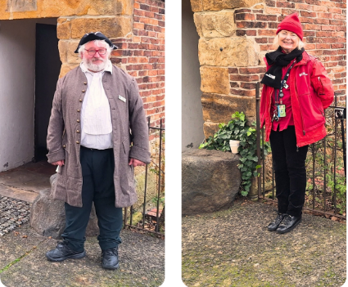

Social Script
- I am going to visit Cooks' Cottage. It is an old house in the Fitzroy Gardens in Melbourne that is famous because it belonged to the parents of Captain James Cook, a famous explorer.
- When I arrive, I will see a charming old cottage with a beautiful garden.
- A friendly staff member will help me with the ticket and provide information about the cottage.
- There may be other visitors there, exploring the cottage and the gardens.
- Inside the cottage, I will see rooms furnished like they were in the 18th century.
- There are displays and information about the history of the cottage and Captain Cook's life. I will need to be careful as I walk because the floors and doorways might be narrow and uneven.
- There will be signs and exhibits that explain the history of the cottage and Captain Cook's adventures. It’s okay to take my time and explore at my own pace.
- Outside, I can walk around the beautiful gardens. There are flowers, plants, and sometimes special displays.
- With all the information and experiences from Cooks' Cottage, I will have a memorable visit.

What To Expect
- When you arrive, friendly staff and volunteers will greet you.
- Staff will give access after you show your ticket.
- As you arrive, our staff and volunteers will give you a welcome introduction.
- Cooks’ Cottage can be experienced alone or with volunteer assistance. You may explore all areas of the cottage including the garden and the Stables.
- Built in 1755, Cooks' Cottage is everything you may expect from an old cottage, it is small, and has stairs and uneven surfaces. We have tried to make the external areas of the cottage as accessible as possible, however limitations with internal access remain.

Getting Here

Travel by tram
- The nearest tram stop is Jolimont Rd/Wellington Parade with routes 48 and 75. The tram stop is approximately 100m from the Fitzroy Gardens Visitor Centre entry.
- These routes offer low-floor tram options. Check Public Transport Victoria for the times of the Low-floor options.
- This stop is outside of the free tram zone.
- A step-free route is available from the tram stops.
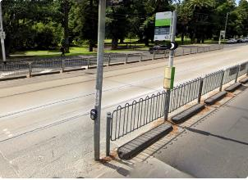

On street parking
- There is limited time-restricted street parking on Wellington Parade.
- Once you are on the footpath, there is a continuous accessible path of travel to the entry. Access to the footpath is via the nearby driveway where there is a kerb ramp.
- Visit Parking for people with disability to find and navigate to parking spaces reserved for people with disability.

Off street parking
- The nearest off street parking is on-site at the visitor centre where there is limited parking.
- One accessible parking bay is available.
- Please visit the City of Melbourne’s Off Street Parking for more information on car park locations and ​​​council-operated car parks.
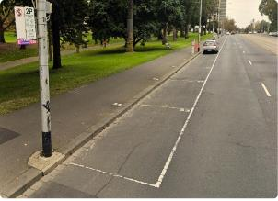

Arrival
- The path approaching the entrance is concrete
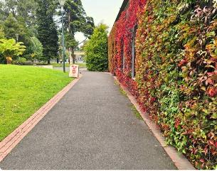
- There is step-free access from the frontage to the entrance.

Entrance
- Clear signage indicates the entrance to Cooks' Cottage.
- A clear and step-free path of travel leads to the entrance.
- Staff will open the gate after they view your ticket.
- The clear gate width is 900mm.
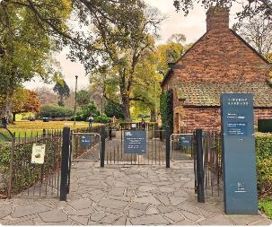
- The ground surfaces are pavers and cobblestone.

Ticket purchase
- Before you enter Cooks’ Cottage, you must purchase a ticket.
- Tickets are purchased at Fitzroy Gardens Visitor Centre, located approximately 40m from the cottage entrance.
- Fitzroy Gardens Visitor Centre offers step-free access.

Entrance to the Cottage
- There is a front and rear entrance to the cottage.
- The front entrance is uneven due to cobblestones and wear of the stone step. The entry width is 890mm.
- The rear entrance has a width of 920mm and a threshold step of 90mm.

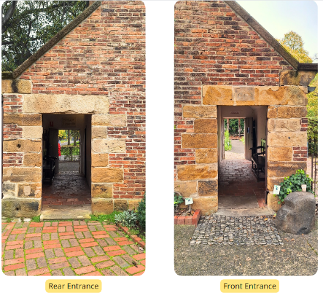

Ground Floor
- There is a step-free entrance to the room with a door width of 720mm.
- The clear floor space of this area is 840mm x 3850mm with restricted circulation space.
- There is an area on display that is zoned off with a rope.
- The flooring is made of large, level stone pavers.
- Lighting varies depending on your position in the room with lux up to 200 near the spotlight.
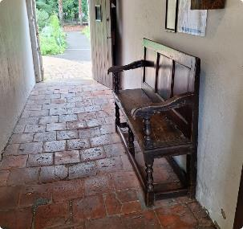
- A bench with armrests is near the entrance with a seat height of 500mm.
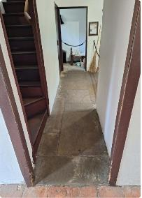

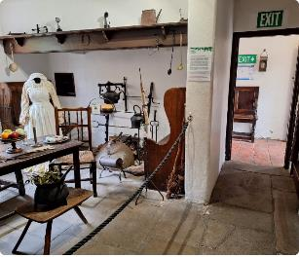

Internal Staircase
- Access to the first floor is via a narrow wooden staircase with twelve stairs.
- A rail on the right side walking up the stairs has a height of 900mm.
- There is low lighting in the stairs approximately 20-30 lux.
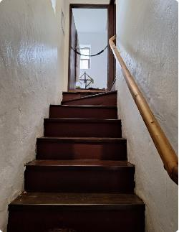

First Floor
- There is reduced circulation space in this area.
- There is an area on display that is zoned off with a rope.
- Lighting varies depending on your position in the room with up to 200 lux near the spotlight.
- The flooring ranges from low pile carpet and floorboards.
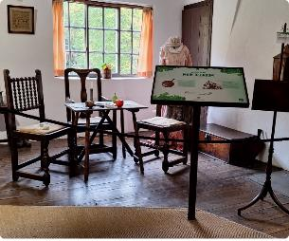

The Stable

Approach to the Stables
- Cobblestones and pebbled concrete lead to the entrance of the Stables.

Entrance to the Stables
- There is step-free access to the Stables, however, the entrance is uneven due to the wear of the stone step.
- The door width is 900mm.
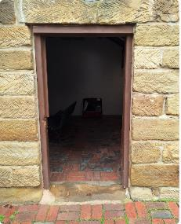
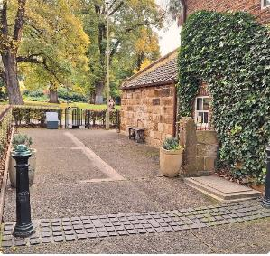

Furniture in the stables
- The bench in the centre of the room has a seat height of 400mm.
- There is clear floor space greater than 1000mm around the seat.

Information display
- A video with closed captions and an interactive, touch-screen television shares more history of the cottage.
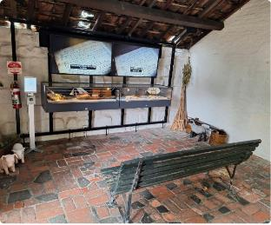

Gardens

Entrance to the gardens
- There is step-free access to the garden, however, the surface may be uneven due to uneven pavers.
- The gate to the garden has a width of 940mm.

Furniture in the gardens
- A bench is positioned near the gate and has a seat height of 400mm.

Garden
- Explore the gardens with informative signs and rich scents. With a collection of fresh herbs picked daily that are a sensory delight and samples of fabrics worn in the 1700s you can immerse yourself in a multi-sensory experience.
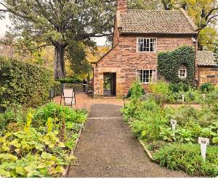
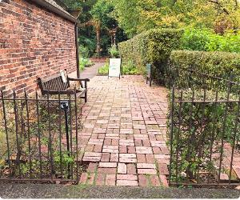

Exit
- Clear signage indicates the exit from Cooks' Cottage.
- A clear and step-free path of travel leads to the exit.
- When exiting you can touch the small green button. Staff and volunteers are always available to assist as needed.
- The gate has a clear width of 900mm.
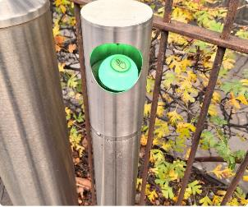
- The ground surfaces are pavers and cobblestones.

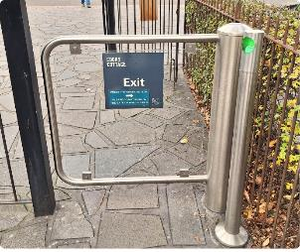
Communication and Information
- On the ground floor and first floor of the cottage, there are audio loops that offer additional information. These are typically set with a low volume however can be adjusted on request.
- A transcription of the audio is available.
- Information in the Stables is delivered via interactive screens and televisions.
- Interpretive signage throughout the venue is available in standard formats. Staff are available to assist with communication and information as needed.
- Communication boards are available on request.

Toilets
- The toilets are located at Fitzroy Gardens Visitor Centre.
- There are Male, Female, Ambulant and Unisex Accessible Toilets.
- There is a baby change table located in the accessible toilet.

Accessible Toilet
- The door of the cubicle swings inward to the left when entering. The door width is 870mm.
- The lever-style door handle has a height of 1000mm. The toilet lock is a traditional style toilet indicator bolt design.
- There is a baby change table provided.
- The toilet seat height is 450mm.
- There is clear floor space to the right of the toilet. The clear floor space to the left of the toilet is 260mm.
- Rails are on the left-hand side and at the rear of the toilet with a height of 800mm.
- The basin is located at a height of 800mm.
- The hand dryer has a height of 1000mm.
- The soap dispenser is installed at 1000mm.
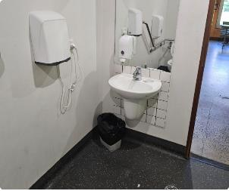
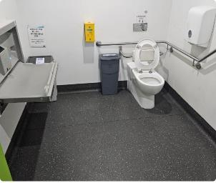
- There is automatic lighting in the bathroom.

Additional Services
- Charging Points: Charging points are available in the visitor centre, please bring your own charging cable.
- Free Wi-fi: Free City of Melbourne Wi-fi can be accessed anywhere in the visitor centre.
- Free Maps and Brochures: Free maps and brochures are available to help plan and inspire your visit.

Sounds
- You may hear the conversations of volunteers and other visitors.
- The volume of other guests will depend on the number of other people visiting the cottage at the same time as you.
- In the cottage, there are audio loops with information about the scene displayed. In the Stables there is a television screen with audio providing more information about the cottage.
- You may hear the sounds of gardeners using equipment to maintain the gardens. This is typically heard between 7.30am to 9am on weekdays. You can call ahead and staff will advise you of the best time to visit to avoid these sounds.

Lighting
- Lighting varies throughout, however, typically the cottage has low lighting.
- The level of lighting is impacted by the level of natural light available on the day.

Scents
- Hand Sanitiser: Hand Sanitiser may be located at the cottage.
- Herbs and Plants: You may experience scents from the herbs and plants in the garden.
- Furniture and Fabrics: In the cottage, you may smell the scent of the old furniture and fabrics.

Temperature Control
- Temperature control is limited. The temperature may vary depending on the season.
- When it is hot in summer a fan is available in the Stable.
- For the cooler weather, there are heaters available in some areas.

Peak Periods
- Peak days and times at the cottage vary depending on the season, school holidays, and what other events are happening in the city.
- In general, the peak periods are Thursdays to Saturdays between 11am - 1pm.
- The cottage is busier during school holidays and days when cruise ships are visiting.
- These peak periods depend on events happening in the city and if you would like more information about the best time to visit, please call ahead and speak with our friendly team.

Additional Helpful Information

Access Map
Visit the City of Melbourne Access Map for more information on accessible amenities.

Mobility equipment hire
Visit Travellers Aid to hire various mobility equipment while you’re in Melbourne.

Recharge points
Visit Services for People with Disability to find your nearest recharge points for your electric scooter or wheelchair. The power points recharge the batteries for standard mobility aides, you will need to bring your own battery charger.

Accessible and Inclusive Melbourne
Visit Accessible and Inclusive Melbourne on our What's On Melbourne website to learn more about local accessible experiences. There's a great range of accessible and inclusive experiences to enjoy in Melbourne.

Acknowledgment of Thanks
The City of Melbourne would like to acknowledge the support and assistance provided by Flare Access Pty Ltd in helping to prepare this Accessibility Guide.

This Accessibility Guide was designed and developed by Flare Access Pty Ltd. For feedback on the guide please contact the City of Melbourne.
Copyright the City of Melbourne June 2024. DISCLAIMER: Accessibility Guide developed by Flare Access. Observations made by Flare Access and additional information provided by the City of Melbourne. All materials have been compiled from information available at the time of production. They are not intended to replace professional advice including; but not limited to, access audits. All necessary care has been taken to design and produce Work(s). All measurements provided are within an approximate range. Full implementation guidelines are supplied in accordance with Work(s) in its entirety. You acknowledge and agree that you are using all services and facilities provided by the City of Melbourne at your own risk and you agree to defend, indemnify, save and hold the City of Melbourne and Flare Access Pty Ltd harmless from any and all demands, liabilities, costs, losses and claims, howsoever suffered, including but not limited to legal fees that may arise directly or indirectly from any service provided or agreed to be provided by the City of Melbourne and Flare Access Pty Ltd. You agree that this indemnification extends to all aspects of the Work(s), including but not limited to implementation and usage. The City of Melbourne and Flare Access Pty Ltd are indemnified of all claims, liability, and expenses that may arise from use of Work(s) as per usage and acceptance of these terms and conditions.

