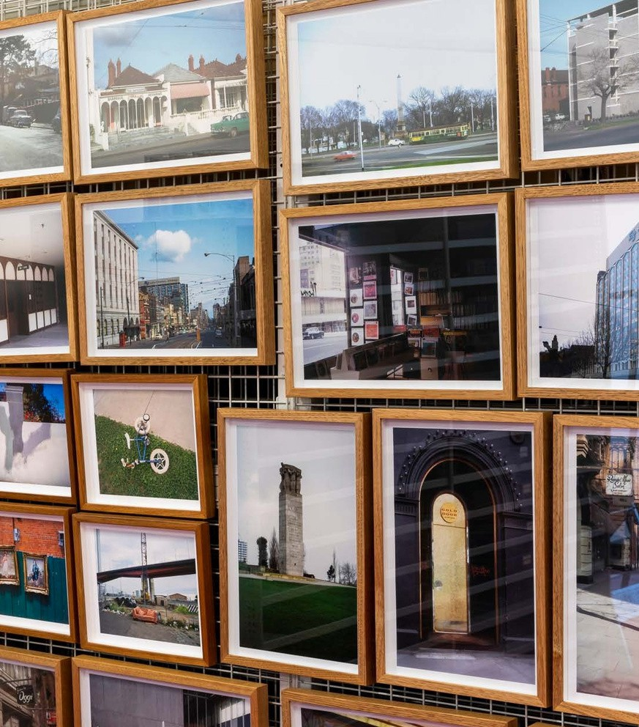
Art and Heritage Collection Tour
Accessibility Guide
Updated April 2026



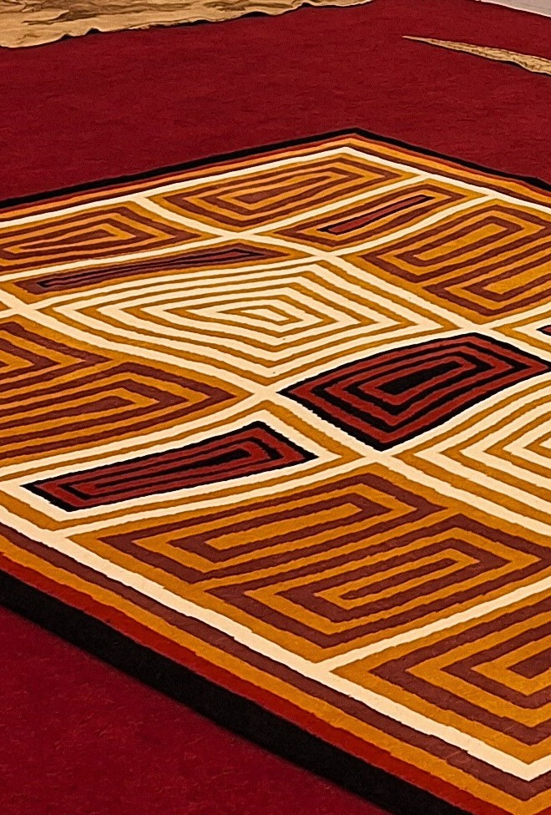

Acknowledgment of Traditional Owners

The City of Melbourne respectfully acknowledges the Traditional Owners of the land we govern, the Wurundjeri Woi-wurrung and Bunurong / Boon Wurrung peoples of the Kulin Nation and pays respect to their Elders past and present. We acknowledge and honour the unbroken spiritual, cultural and political connection they have maintained to this unique place for more than 2000 generations.

We accept the invitation in the Uluru Statement from the Heart and are committed to walking together to build a better future.

2


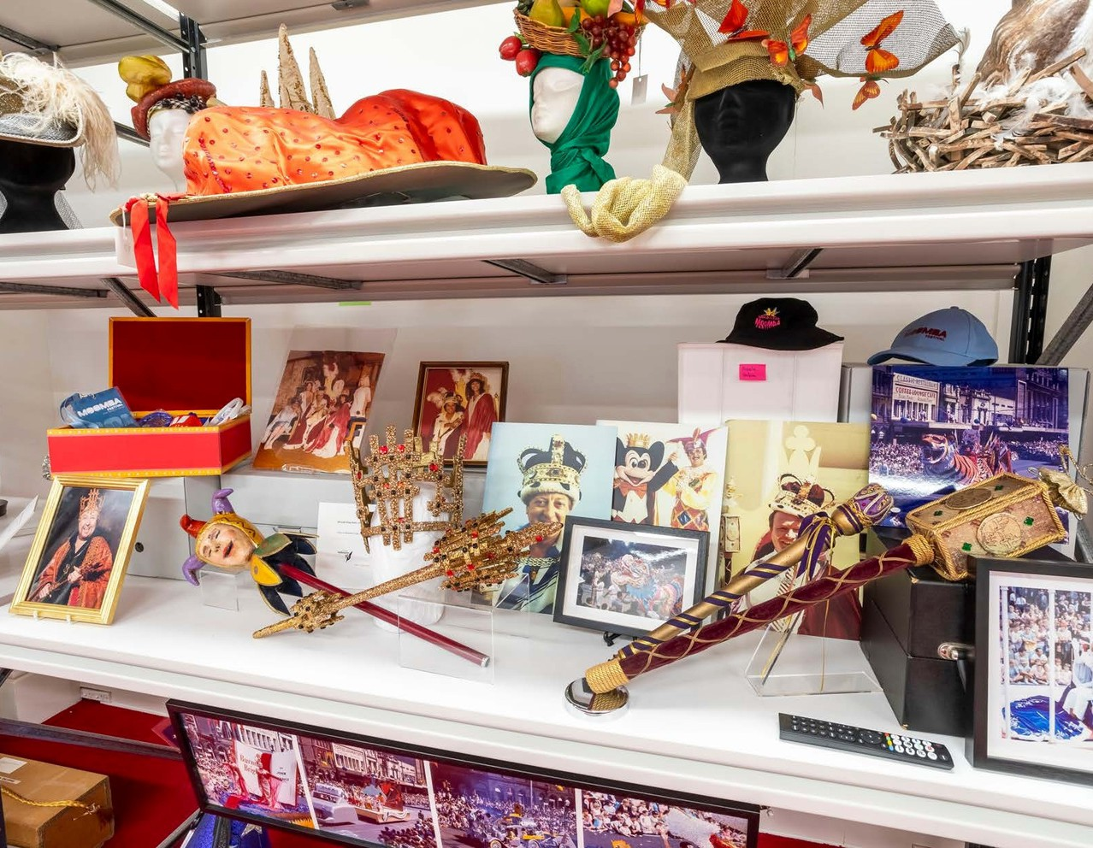
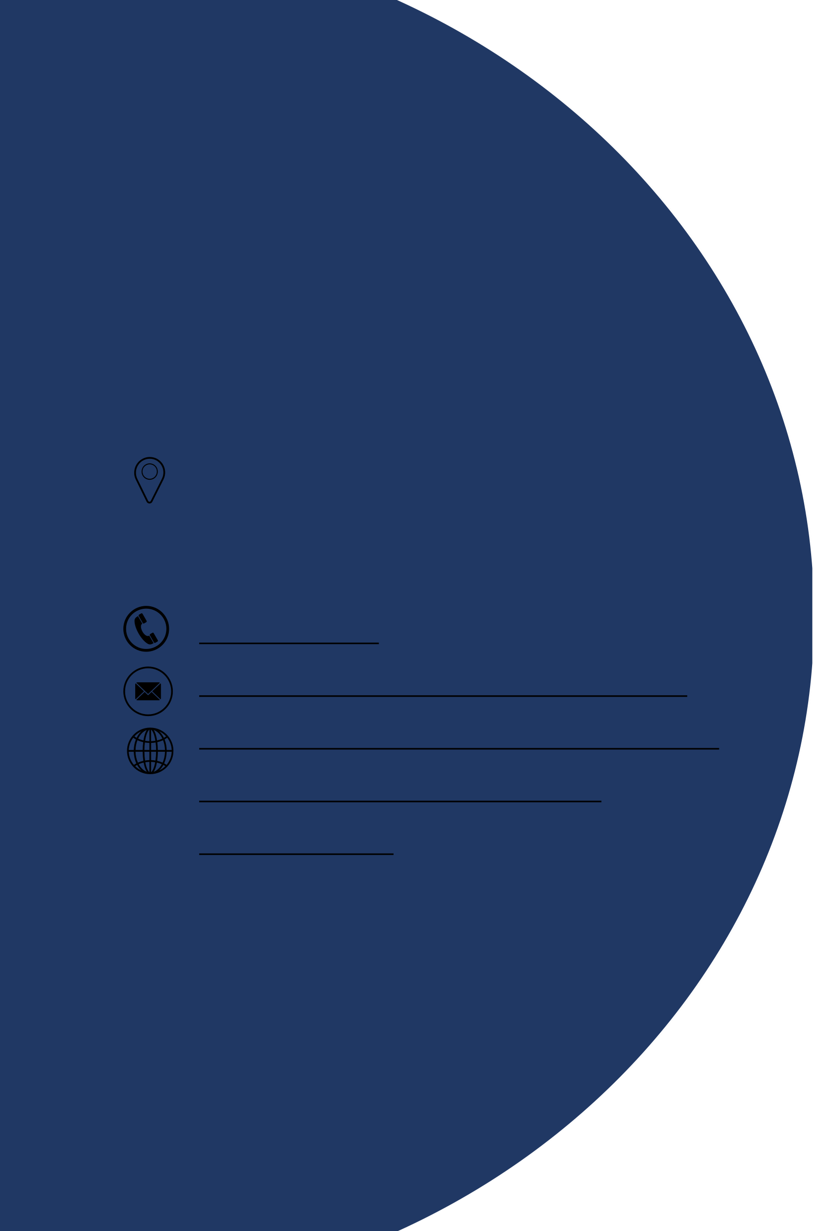

Contact us
Melbourne Town Hall 90-130 Swanston Street
Melbourne 3000
03 9658 9658
citycollection@melbourne.gov.vic.au https://whatson.melbourne.vic.gov.au/ things-to-do/art-and-heritage-collection-tour

3

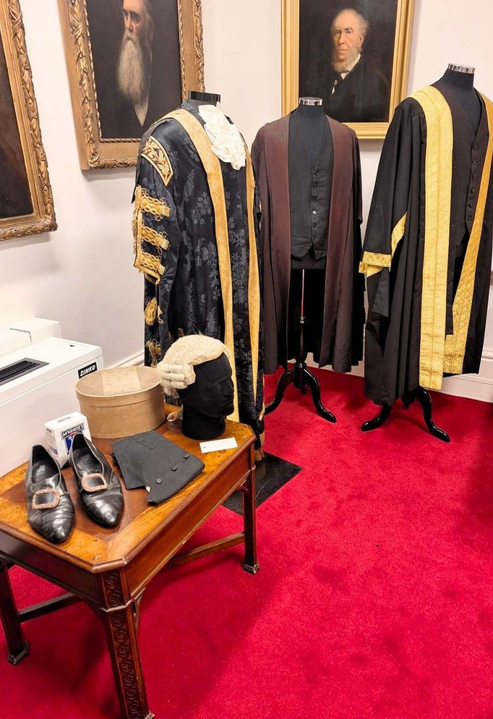
Contents
3
Acknowledgment of Traditional Owners 2
Contact us 3
Welcome 5
Access At A Glance 5
Tour Guides 6
Social Script 7
What to Expect 8
Getting Here 10
Arrival 12
Security Concierge 13
Beginning the Tour 14
Security Gates 15
The Lift 16
During the Tour 17
Things You Will See 18
Seating and Rest Areas 24
Adult Change Room 25
Accessible Toilets 26
Signage and Information 27
Sounds 28
Lighting and Visual Stimulus 28
Scents 29
Additional helpful information 30

4

Welcome

Take a free guided tour of the City of Melbourne Art and Heritage Collection store, located in the historic Melbourne Town Hall.
The entire fourth floor has been refurbished as an open display collection ready for the public to discover. The collection is eclectic and includes over 15,000 items. Explore a range of objects including public art, maquettes, street art, Moomba, Olympics, photography, works by First Nations artists, books, plans, Council and ceremonial and contemporary art including works related to the Metro Tunnel Project.

Access At A Glance

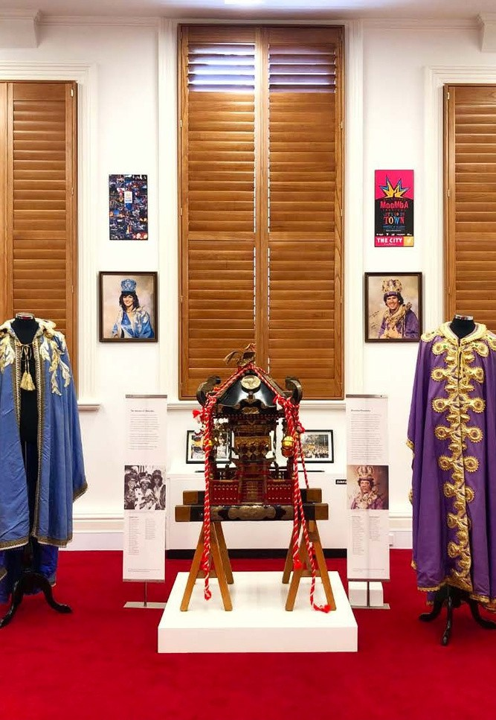

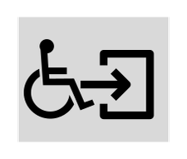
Accessible Toilet

Accessible Parking
P

Accessible Adult Change with Hoist
Step Free Access

Baby Changing Table

Portable Assistive Listening Device
5 4


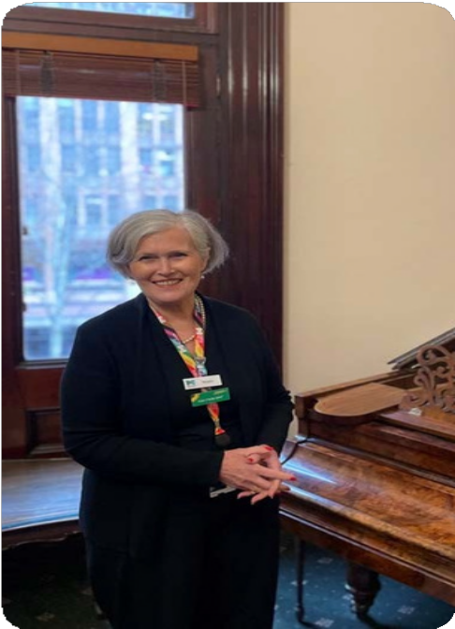
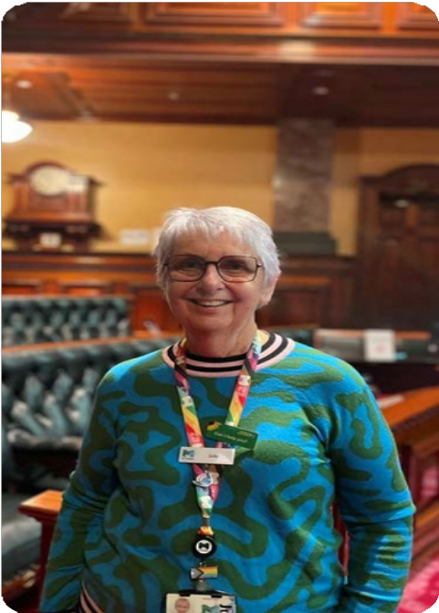
- We have a diverse and friendly team of guides available to lead your tour.
Tour Guides

- Tour guides wear casual clothing and name badges with large, clear text.

- Guides also wear colourful City of Melbourne lanyards, which help you easily recognise them as official tour guides.

- After you go through security, your tour guide will meet you and will be with you throughout the tour.

- Guides will share historical insights about the Art and Heritage Collection, introduce significant figures and highlight key events in the city’s history.

- Our guides are trained on the Sunflower Scheme and are happy for you to ask questions throughout the tour.

- Please ask for permission before you take photos of your guide.

We look forward to welcoming you on the tour and exploring the rich history of the Art and Heritage Collection together!

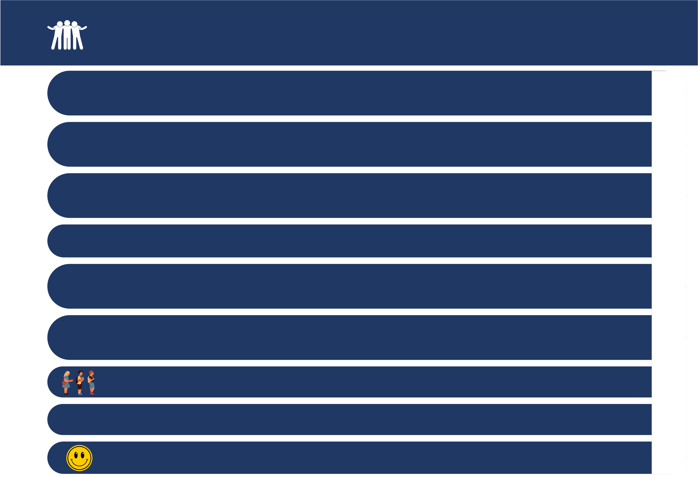

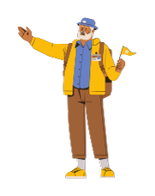
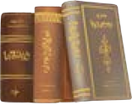




Social Script

During the Art and Heritage Collection tour, I will hear about and see interesting pieces of art and historical items that tell the story of the City of Melbourne.

Before I start the tour, I will go through security. My bag will be scanned using an x-ray machine and I will sign in using a QR code. If I need help, a friendly staff member at the front desk will be there to assist me.

A Tour Guide will take me to different rooms in Melbourne Town Hall and share stories and information. There might be other people joining me who are also on the tour.

My Tour Guide wears casual clothing, a name badge and a lanyard around their neck so they'll be easy to recognise.

They know a lot about the Art and Heritage Collection and I can ask them any questions I have. I can also speak with other people in the group if I want to.

I can choose to explore the rooms we visit, and there will be lots of interesting things to see in each room. If I need a break, I can let my Tour Guide know. There are places to sit and relax if I need to take a breather.

I might need to wait my turn to see items on display, but there will be plenty of time to see everything I want to.

I will get to see lots of exciting things on the tour but we will be asked not to touch any of these items.

I had a really good time on the Art and Heritage Collection tour and I learned a lot about the city's history.

What To Expect

The tour lasts approximately one hour and is indoors.

You will visit approximately 11 rooms in Melbourne Town Hall,
Hours of Operation

spending around 5 minutes in each.
Monday
2.30pm - 3.30pm

Rooms you may visit include:
Moomba/ Olympics/ Public art/ Street Art Room Managing the City Room
Melbourne Photography Room First Nations Artists Room Books and Plans Room
City Gifts Room
Council and Ceremonial Room Making Metro Tunnel Artworks Room Miscellaneous Melbourne Room Workroom and Picture Rack Room

The items we have on display are only a selection of the collection.
Tuesday

Wednesday

Thursday

Friday Saturday
Sunday
Closed

2.30pm - 3.30pm

2.30pm - 3.30pm 2.30pm - 3.30pm Closed
Closed

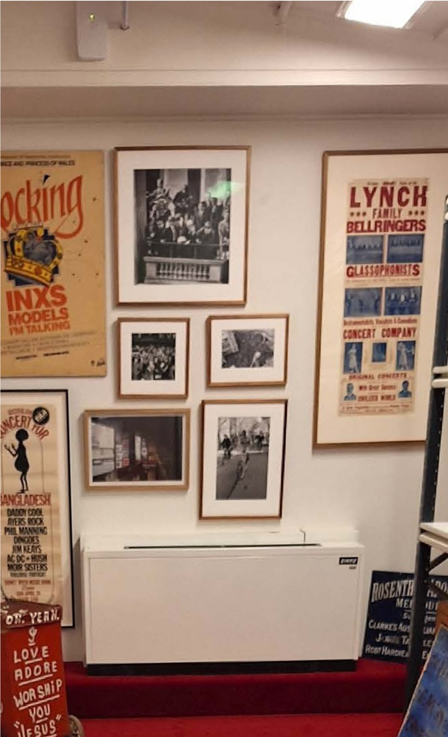
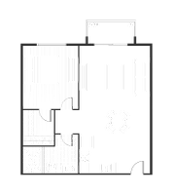
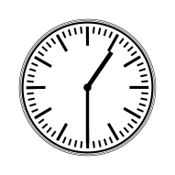

Items in these photos may not be on display during your visit. We do not operate on public holidays.

This tour does not include a tour of the Melbourne Town Hall.

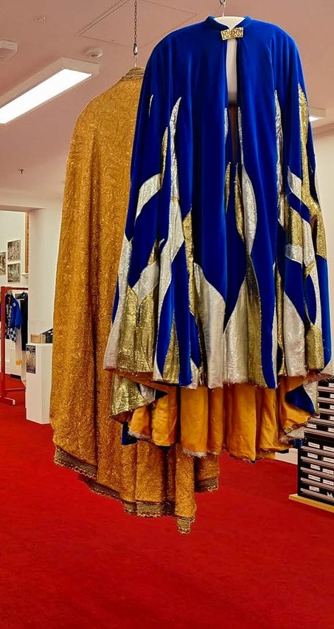
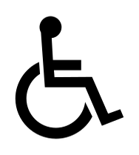


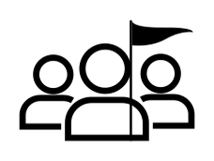
What To Expect

- Your Tour Guide will meet you after you have cleared security. There
- may be others joining you on the tour. Everyone is there to learn and enjoy Melbourne’s artistic and cultural history. You will be guided
- through various rooms and areas of Town Hall with the Tour Guide sharing stories and information at different points.

- You can take photos and ask questions throughout the tour.
- Photos are permitted in the rooms and corridors.
- Some areas that you visit are shared with staff working at Town Hall. We ask that you respect their privacy and avoid taking their photos.

- Some rooms and hallways have seats. Please request a seat if you would like a rest break.
- There is step-free access throughout the tour. There are slight inclines and declines when accessing different rooms.

- Melbourne Town Hall is a heritage building and wheelchair access is limited in some areas. While the lift is wheelchair accessible, some of the doorways on this tour may not be wide enough for some wheelchairs. Please email: citycollection@melbourne.gov.vic.au if you have any questions.
- A wheelchair is available for use during the tour. Please book this in advance. Accessible toilets and Changing Places are available on the

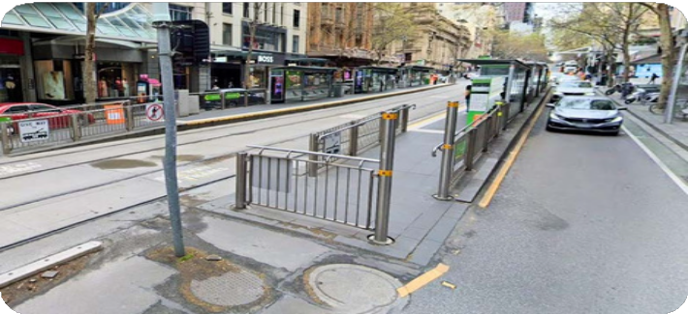
Travel by tram
Getting Here
- The nearest tram stop is Melbourne Town Hall/Collins Street #6 with routes 109, 11, 12, 48. The tram stop is approximately 95m from the Melbourne Town Hall entry.
- The next closest tram stop is City Square/Swanston Street with routes 1, 16, 3, 5, 6, 64, 67, 72. The tram stop is approximately 105m
from the Melbourne Town Hall entry. Tram routes 109, 11, 48, 5, 6, and 16 all offer low-floor tram options.
- Check Public Transport Victoria for the times of the Low-floor options. These stops are included in the free tram zone. A step-free route is available from the tram stops.

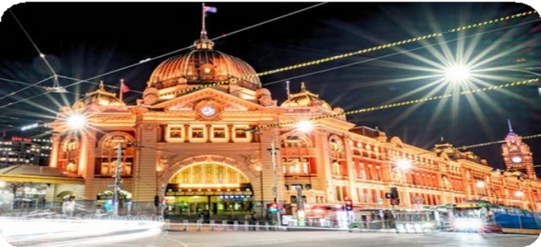
Travel by train

Flinders Street Station
- This station has accessible station access.
- The station is approximately 300m from the Melbourne Town Hall entry.
- A step free route is available from the train station.

Melbourne Central Station
- This station has accessible station access.
- The station is approximately 550m from the Melbourne Town Hall entry.
- A step free route is available from the train station.

10

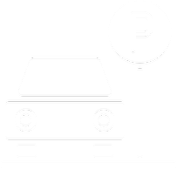
Travel by car
Getting Here

On street parking
- There is limited time-restricted street parking on Collins Street including accessible parking.
- Once you are on the footpath, there is a continuous accessible path of travel to the entry. Access to the footpath is via the nearby traffic lights where there is a kerb ramp.
- Visit Parking for people with disability to find and navigate to parking spaces reserved for people with disability.

Off street parking
- The nearest paid off- street parking is 233-239 Collins Street.
- This parking is approximately 100m from the Melbourne Town Hall entrance.
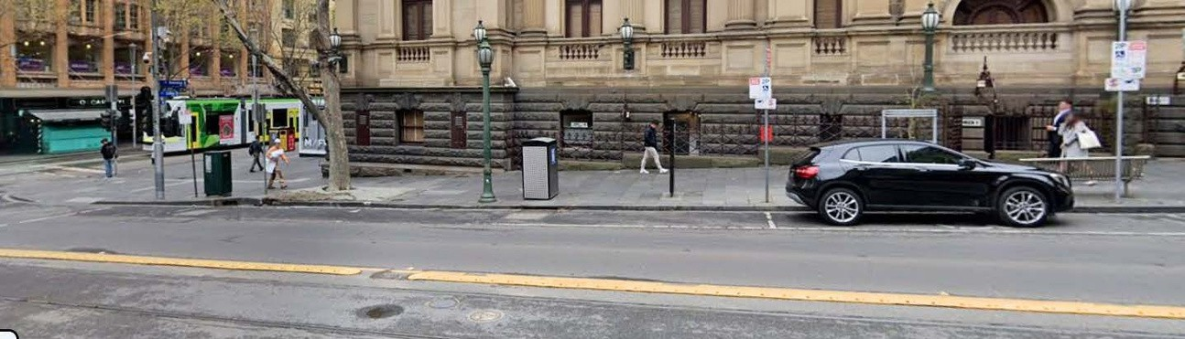
- Please visit the City of Melbourne’s Off Street Parking for more information on car park locations and Council operated car parks.
11

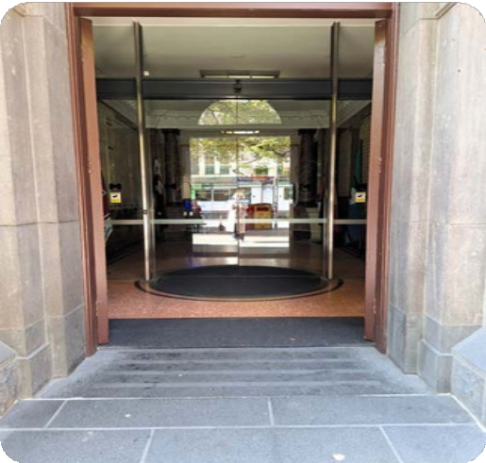



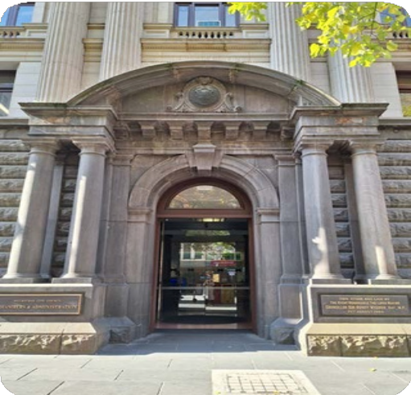

Meeting Point
Arrival
The meeting point for the tour is located inside the Administration Building door, Melbourne Town Hall, 90-130 Swanston Street.

  - The path to the main entrance is paved.
  - There is step-free access from the frontage to the main entrance.

Main entrance
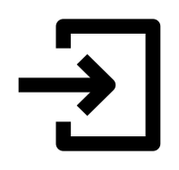
  - Thereisa clear and step-free path of travel to the main entrance.
  - Automatic glass sliding doors with visual markings open to the Concierge.
  - The clear door width is greater than 1000mm.

What to expect
Security Concierge
  - Arrive 15 minutes prior to your tour to allow time to go through security.


  - You will be asked to pass your personal belongings through an x-ray machine.
  - The security process is flexible and may be adapted to suit your access needs.
  - If you are seated in a wheelchair, security will conduct a visual security assessment of your wheelchair.
  - If you have large items such as prams, luggage, or large backpacks, you will be asked to leave them in the cloakroom. There is a limited cloak area.


  - You will be asked to show your photo identification and sign in using a QR code at the Concierge, staff can assist you as necessary.
  - A visitor pass and lanyard will be provided that you can wear around your neck. This will be returned to the Concierge at the end of the tour.
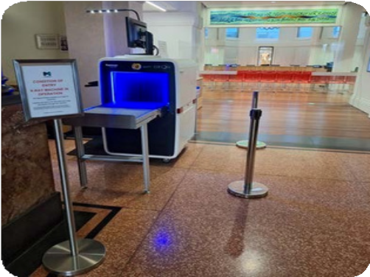
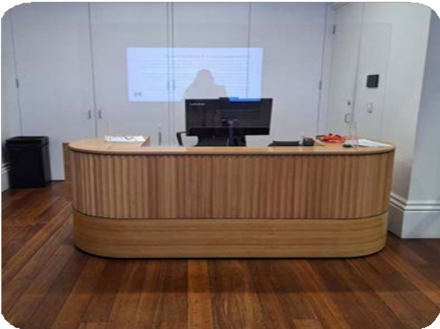
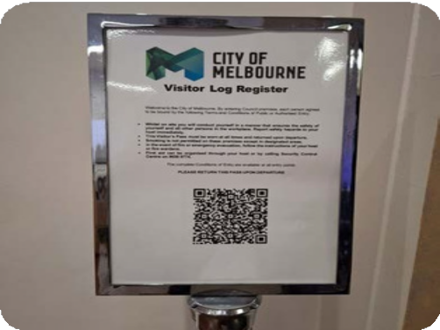
  - The service counter has a height of 850mm and there is clear floor space in this area.


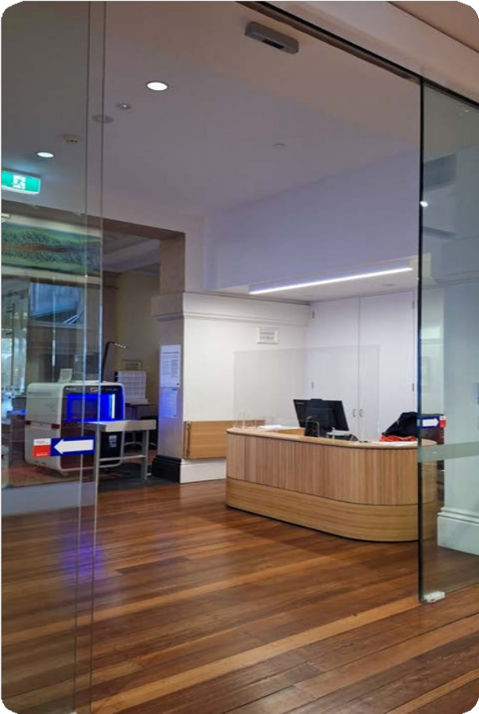
- After signing in, you will enter the Melbourne Town Hall Commons through automatic glass sliding doors that have a width greater than 1000mm.
Beginning the Tour
- You will meet your Tour Guide in the Melbourne Town Hall Commons. Seating is
- available in this room as you wait, with firm chairs without armrests.
- There may be other people waiting in the Town Hall Commons to join the same tour.

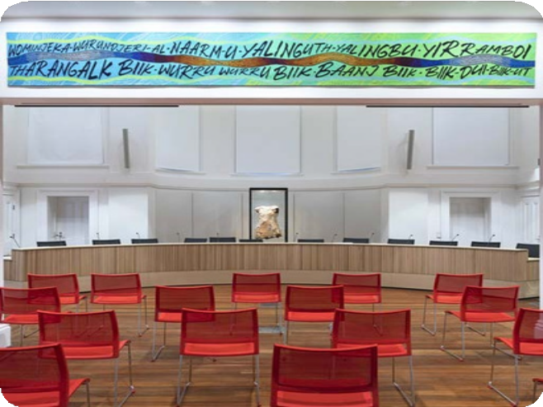
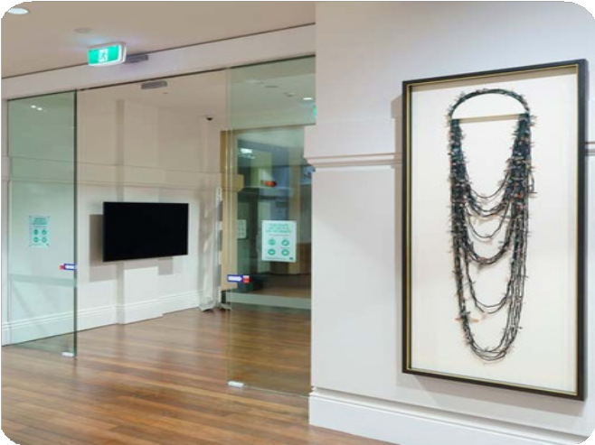

- After the Town Hall Commons, the first room you visit on the tour, you will pass through security gates.
Security Gates
- You will scan your visitor pass and the doors will open. Staff can assist you as needed.
- The gate has glass doors that will retract as you enter.
- The width of the gate is 930mm.

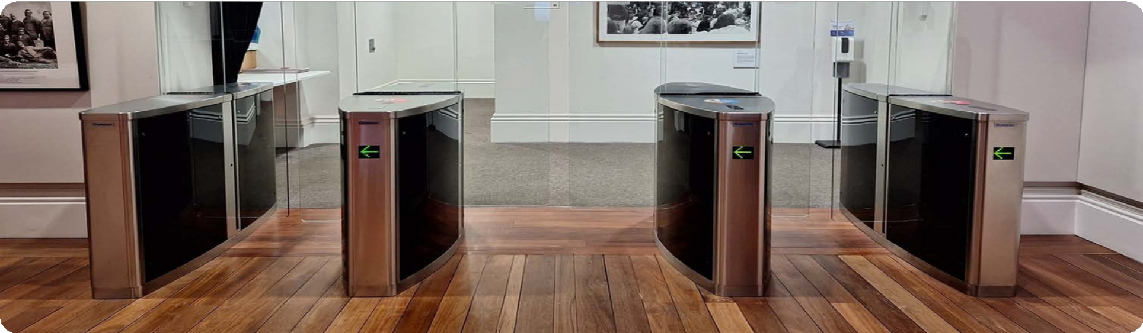



- Your Tour Guide will accompany you to level 4 in the lift and will assist with directions.
The Lift
- Braille and tactile indicators are available on the lift buttons.
- The lift has dimensions of 1740x 1220mm.
- A handrail is available in the lift.

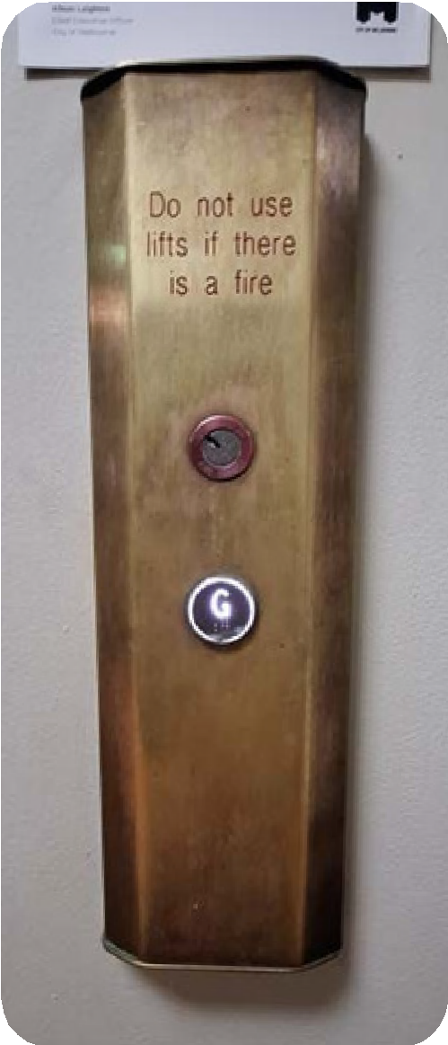
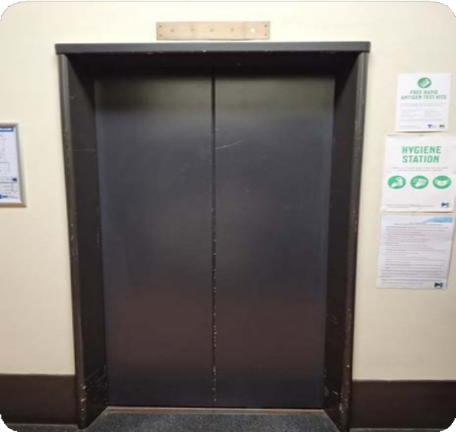
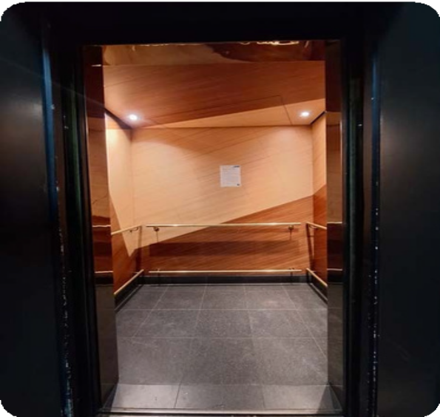
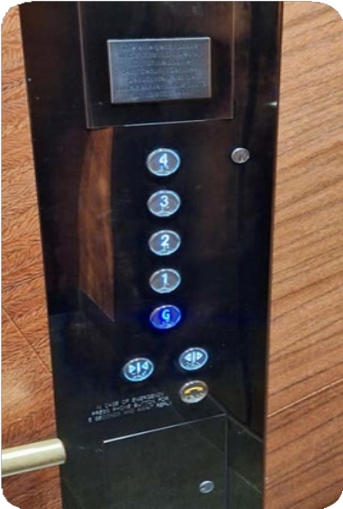

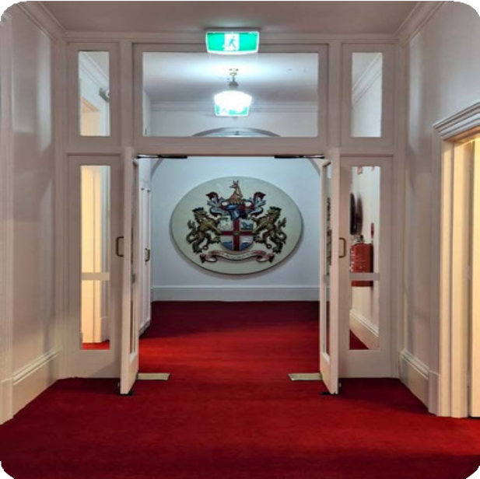
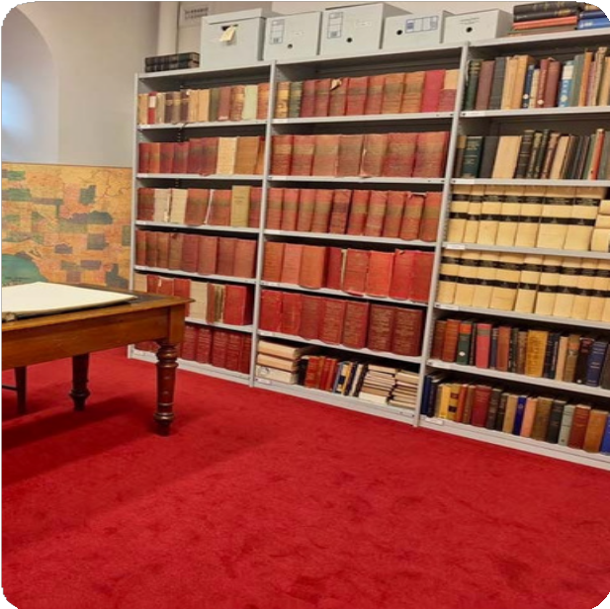
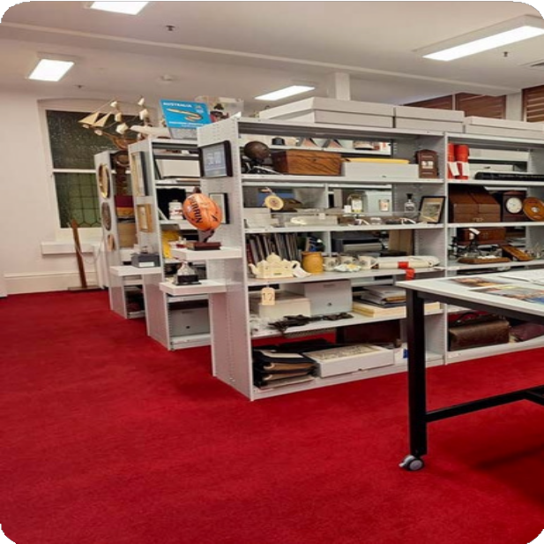


- Melbourne Town Hall is a heritage building and access is limited in some areas.
During the Tour
- There is step-free access throughout the tour.
- The flooring throughout the tour is mostly low to medium-pile carpet. Medium pile carpet can be difficult to push trolleys on and may impact how easy it is to push a wheelchair.
- Some of the doorways may not be wide enough for some wheelchairs.
- There is adequate clear floor space in most areas of the tour, however, some rooms have restricted clear floor space that will limit turning and maneuvering.

17

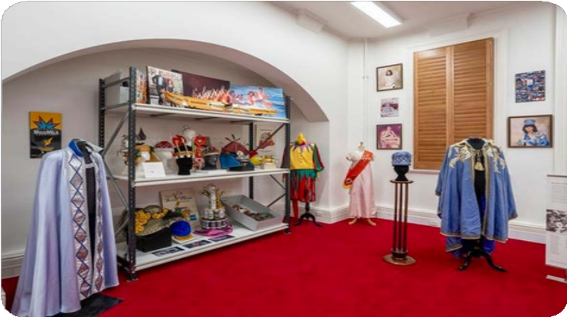

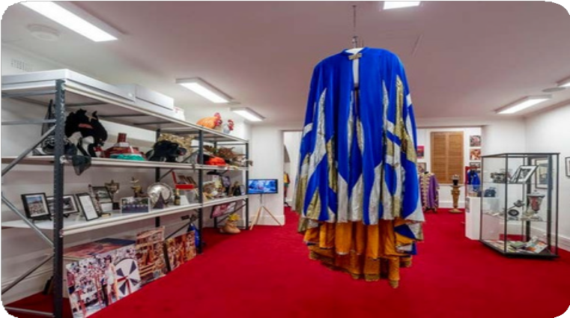
Moomba/ Olympics/Public art/ Street Art Room
Things You Will See
- The clear door width is 850mm.
- There is unrestricted clear floor space.

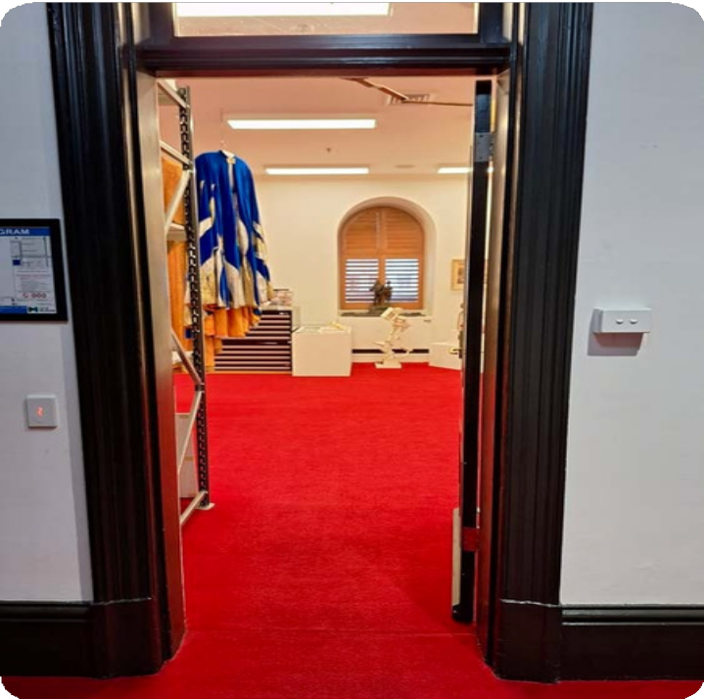

Managing the City Room Melbourne Photography Room
Things You Will See

- The clear door width through the connecting door is 800mm.
- The clear door width from the corridor is 850mm.
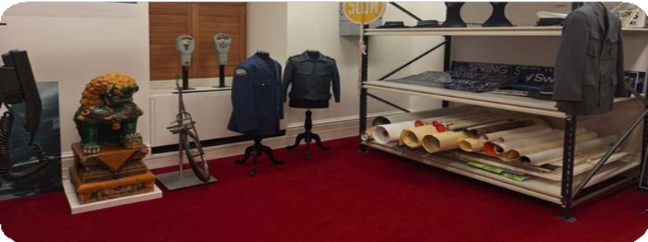
- There is unrestricted clear floor space.
- The clear door width through the connecting door is 800mm.
- The clear door width from the corridor is 860mm.
- The display cabinet is wheelchair accessible, with a height of 800mm with knee and foot clearance.
- There is unrestricted clear floor space.

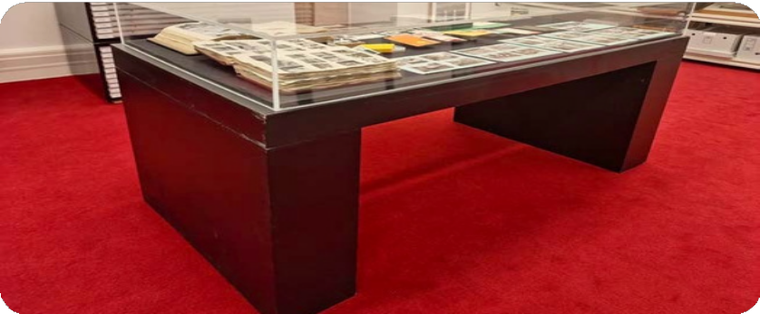
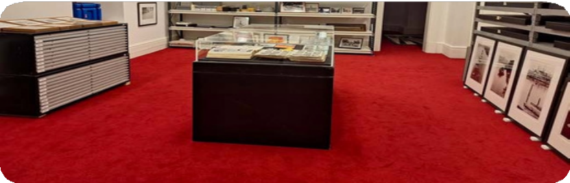
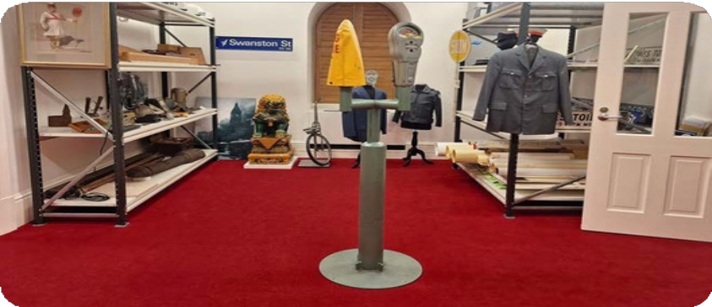

First Nations Artists Room
Things You Will See
  - The clear door width through the connecting door is 890mm.
  - Clear floor space is restricted in some areas.

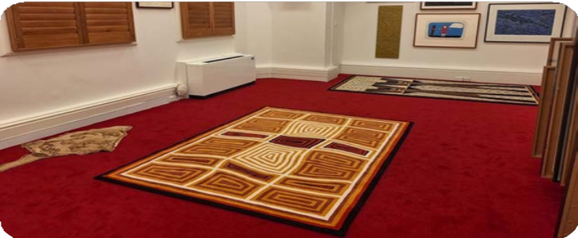

Books and Plans Room
  - The clear doorwidth from thecorridor is 800mm.
  - There is unrestricted clear floor space.
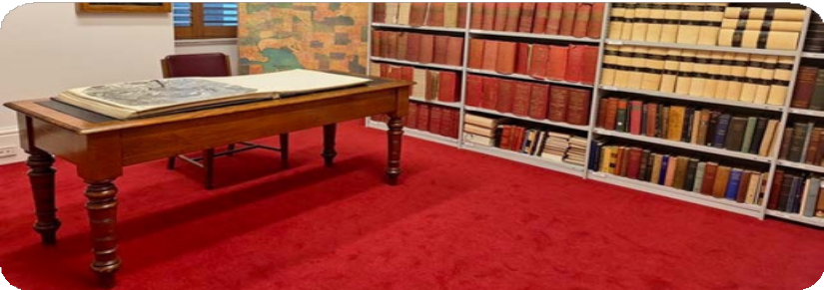

City Gifts Room
  - Clear door width is 960mm from the corridor
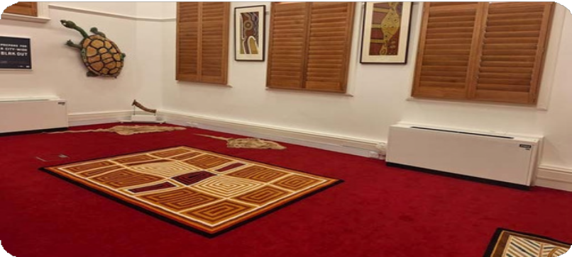
  - There is unrestricted clear floor space.

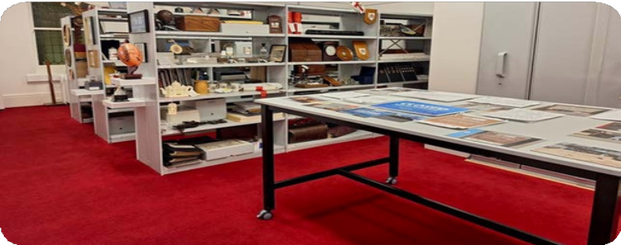

Council and Ceremonial Room Making Metro Tunnel Artworks Room
Things You Will See

- The clear door width is 770mm.
- The display cabinet is wheelchair accessible at a height of 760mm with knee and foot clearance.
- This is a smaller room but there is unrestricted clear floor space.
- The clear door width is 880mm.
- There is unrestricted clear floor space.


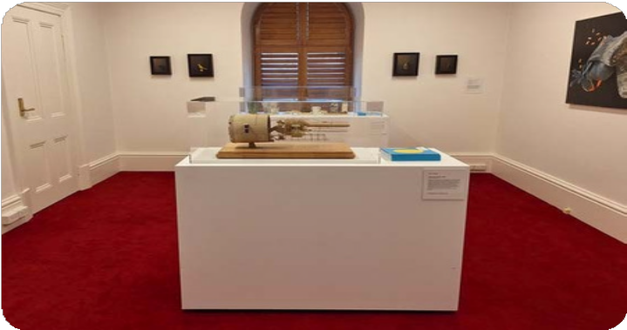
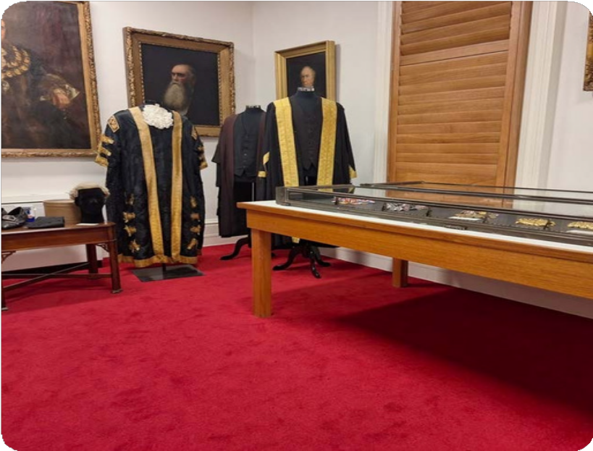

Miscellaneous Melbourne Room
Things You Will See
- The clear door width is 700mm.
- There is a ramp with handrails down into the room.
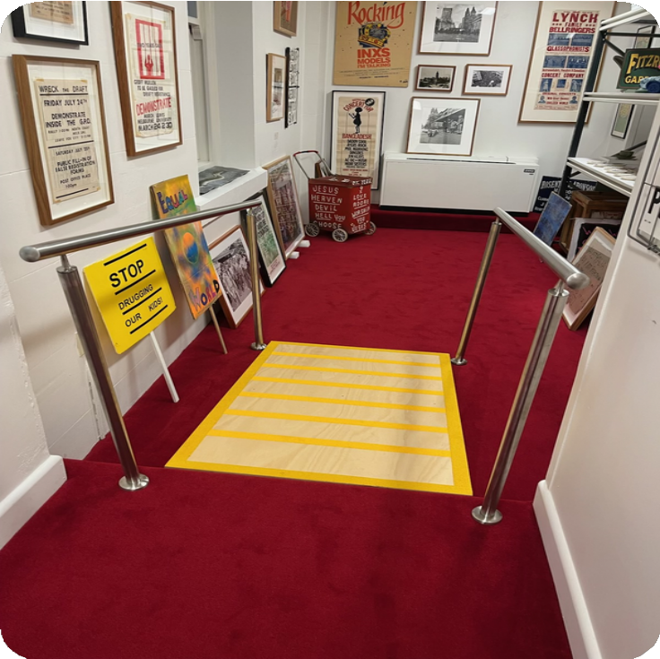
- There is restricted clear floor space which may make it difficult to maneuver with mobility aids.
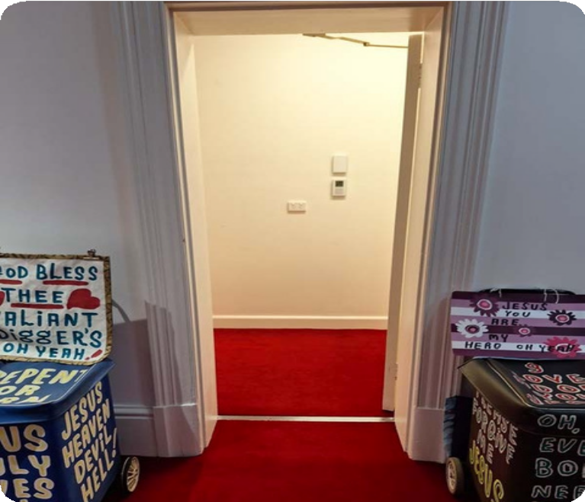

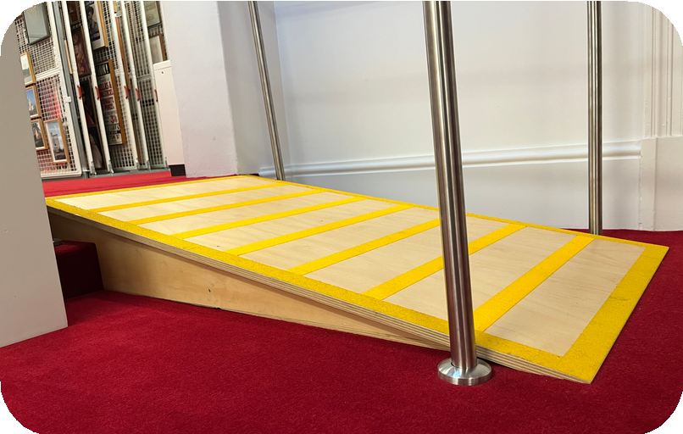
Workroom and Picture Rack Room
Things You Will See
- The clear door width is 850mm.
- There is a ramp with handrails leading up into the room.
- There is unrestricted clear floor space.

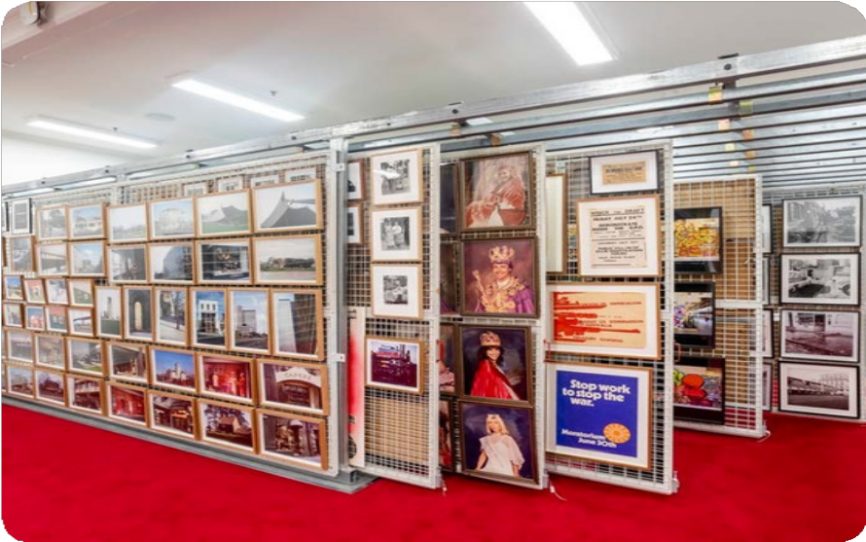
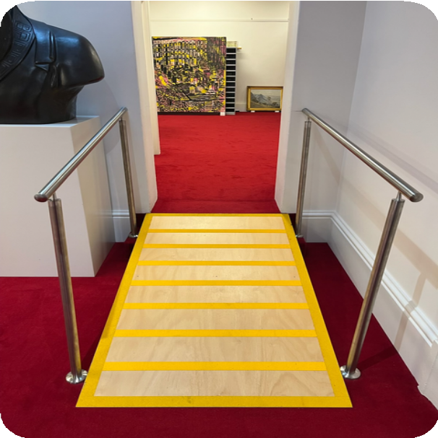

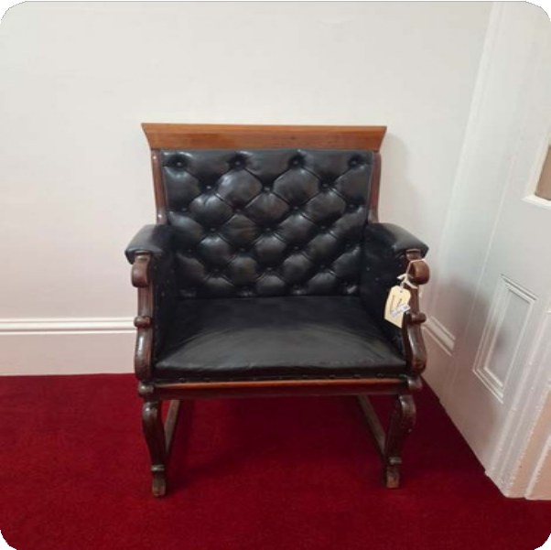
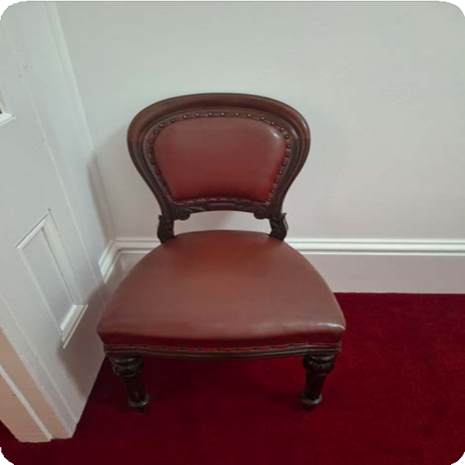

- Throughout the tour, you will have opportunities to rest and take a break if needed.
Seating and Rest Areas
- If you would like a break during the tour, please inform your Tour Guide and they will find the nearest place to take a break.
- There are various seating options with and without armrests.

24

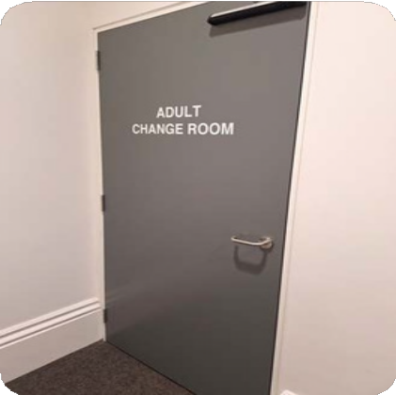
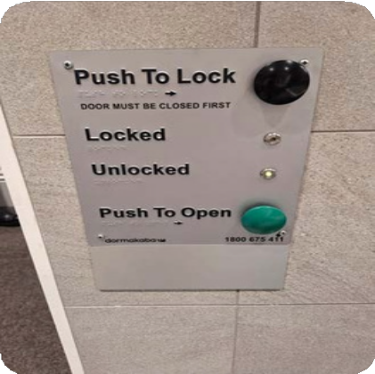
Location: Ground floor, Melbourne Town Hall
Adult Change Room
- Accessed via an MLAK key which is available from Security.
- You will have the opportunity to use the facilities before and after the tour, there is limited opportunity to visit the facilities during the tour.
- There is an adult changing facility with a ceiling hoist.
- A shower with a handheld shower hose and fold-down shower chair.
- Privacy screen.
- An accessible toilet with drop-down rails on the right and left side.
- A manual wheelchair is available for use.
- Visit Getting Around Melbourne to find more Adult Change rooms in the city.
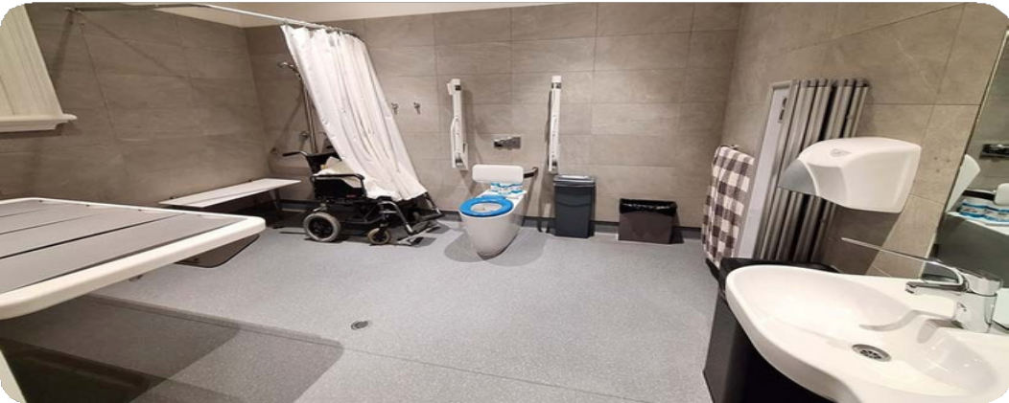
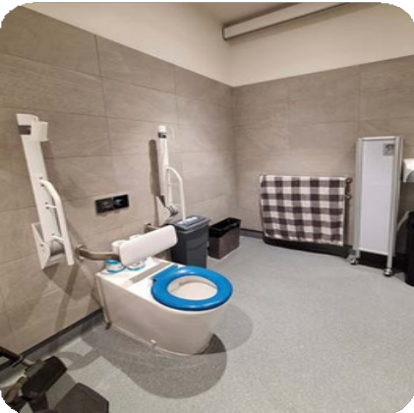
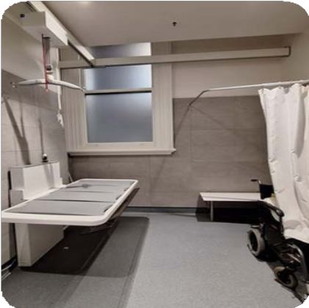


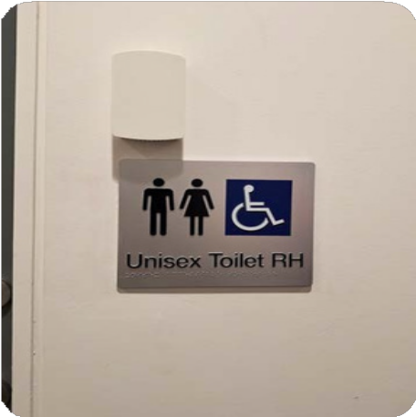
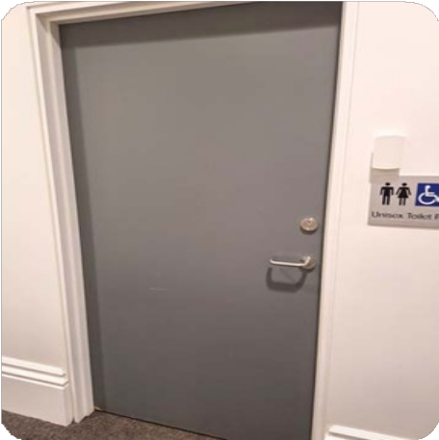
Location: Ground floor, Melbourne Town Hall
RHS Accessible Toilet
You will have the opportunity to use the facilities before and after the tour, there is limited opportunity to visit the facilities during the tour.


The manual door is inswinging to the left and has a clear width of 860mm.
The door to enter the toilet has a D-shaped lever
handle with a height of 1000mm.
There is a long lever lock.

The toilet has a height of 450mm.
The clearance on the right side of the toilet is 270mm and on the left it is open.
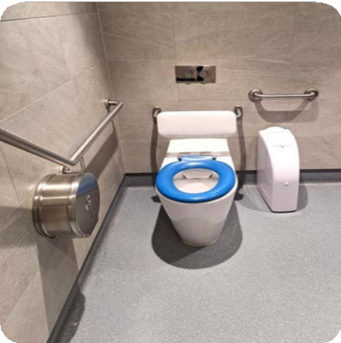
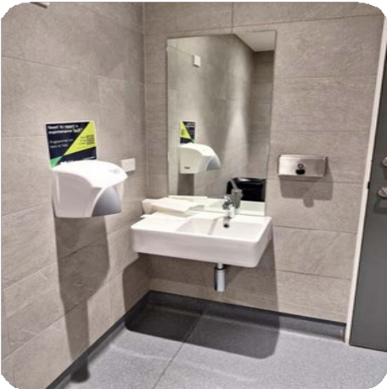
Grab rails are located on the right side and rear of the toilet and are positioned with a height of 800mm.

The basin has a height of 1100mm with a lever-style tap.
The soap dispenser has a height of 1000mm.
The hand dryer is positioned next to the basin with a height of 1000mm.

Lighting is automatic.

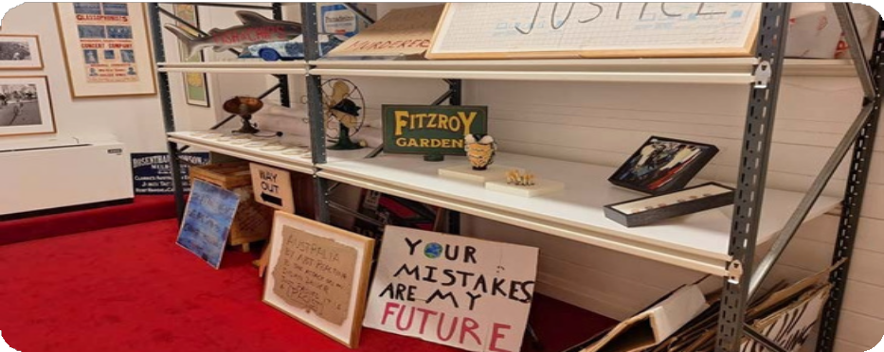
- Our Tour Guides deliver information verbally.
Signage and Information
- There are informational signs and printed material throughout the tour and staff can assist with reading and sharing this information.
- A portable Assistive Listening Device is available. Please contact us in advance if you would like to book this device for your tour.
- Signage with Braille indicates key areas including the toilets and lift.

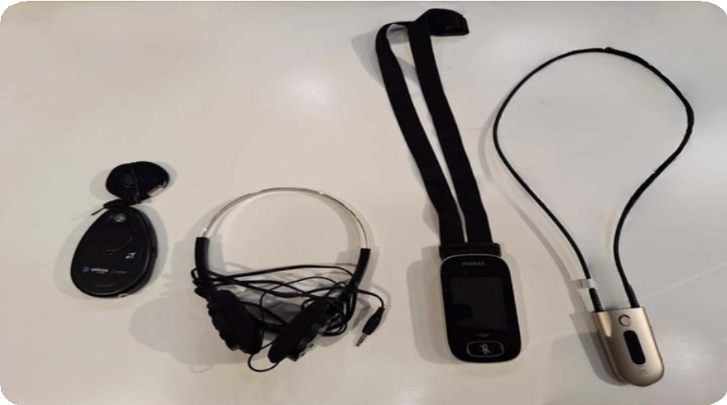
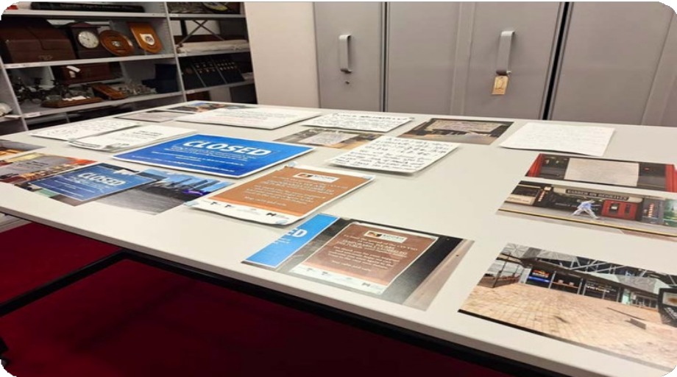

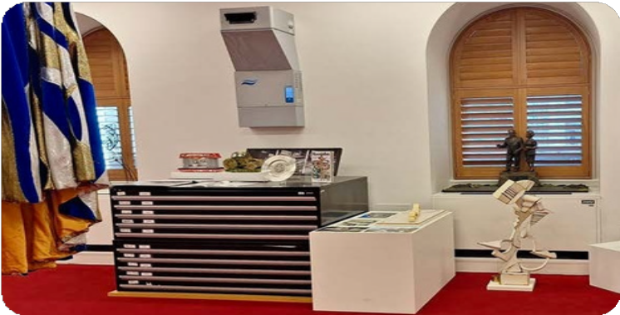

There are typically few sounds in the Art and Heritage Tour besides the Tour Guide and other guests.
Sounds
The volume of other guests will depend on the number of other people enjoying the tour on the day.

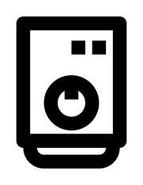
In some rooms, you may hear the gentle hum of the dehumidifier.
There are occasional beeping alarm sounds.

If it gets loud or if you would like some quiet during the tour, you can wear your personal headphones.
Lighting and Visual Stimulus

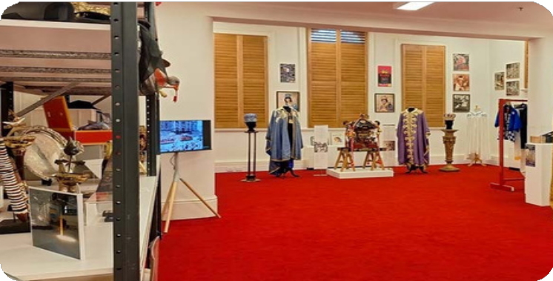
There are TV screens in two areas of the tour.
Lighting cannot be adjusted as all lighting is automatic.
Lighting is mostly consistent throughout the tour at 700 lux.
There is minimal glare throughout the tour.


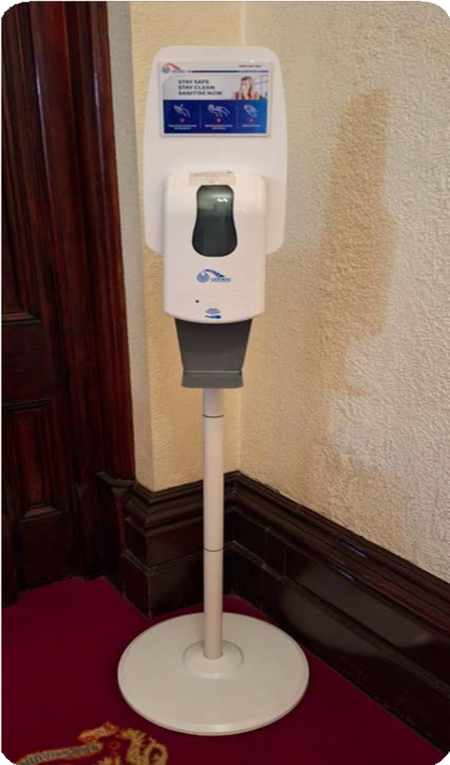

Food
Scents
You may occasionally smell the food of Council staff members.

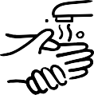
Hand wash
Mildly scented hand wash is located in the bathrooms.

Hand Sanitiser
Hand Sanitiser may be located in the bathrooms and other rooms that you visit.

Air freshener
Air fresheners may be located in the bathrooms and may be used in other rooms that you visit.

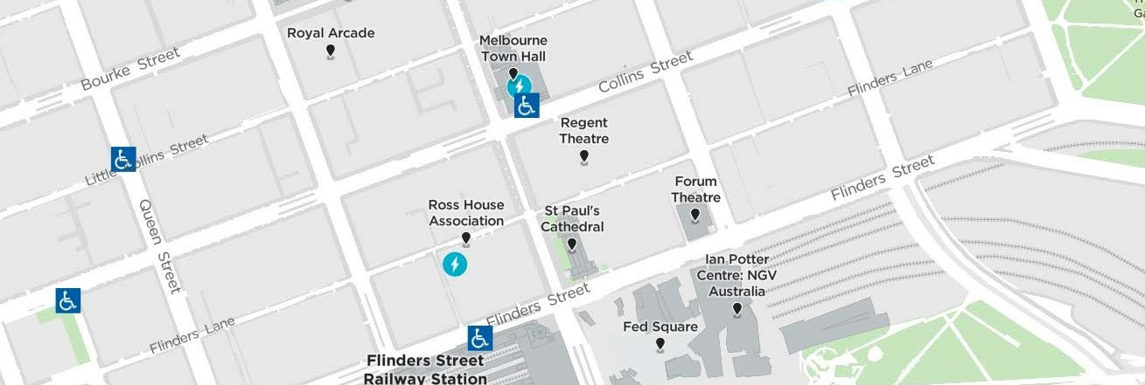
30


Access Map
Additional helpful information
Visit the City of Melbourne Access Map for more information on accessible amenities.



Mobility equipment hire
Visit Travellers Aid to hire various mobility equipment while you’re in Melbourne.

Recharge points
Visit Services for People with Disability to find your nearest recharge points for your electric scooter or wheelchair. The power points recharge the batteries for standard mobility aides, you will need to bring your own battery charger.



Acknowledgment of thanks
The City of Melbourne would like to acknowledge the support and assistance provided by Flare Access Pty Ltd in helping to prepare this Accessibility Guide.


This Accessibility Guide was designed and developed by Flare Access Pty Ltd. For feedback on the guide please contact the City of Melbourne.

Copyright City of Melbourne April 2026. DISCLAIMER: Accessibility Guide developed by Flare Access. Observations made by Flare Access and additional information provided by the City of Melbourne. All materials have been compiled from information available at the time of production. They are not intended to replace professional advice including; but not limited to, access audits. All necessary care has been taken to design and produce Work(s). All measurements provided are within an approximate range. Full implementation guidelines are supplied in accordance with Work(s) in its entirety. You acknowledge and agree that you are using all services and facilities provided by the City of Melbourne at your own risk and you agree to defend, indemnify, save and hold the City of Melbourne and Flare Access Pty Ltd harmless from any and all demands, liabilities, costs, losses and claims, howsoever suffered, including but not limited to legal fees that may arise directly or indirectly from any service provided or agreed to be provided by the City of Melbourne and Flare Access Pty Ltd. You agree that this indemnification extends to all aspects of the Work(s), including but not limited to implementation and usage. The City of Melbourne and Flare Access Pty Ltd are indemnified of all claims, liability, and expenses that may arise from use of Work(s) as per usage and acceptance of these terms and conditions.

31

